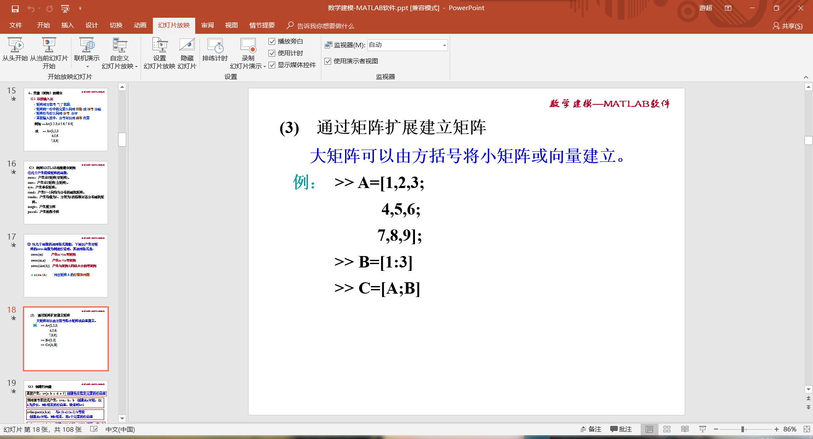

>> A=[1 2 3

4 5 6

7 8 9]

A =

1 2 3

4 5 6

7 8 9

>> B=[1:3]

B =

1 2 3

>> C=[A;B]

C =

1 2 3

4 5 6

7 8 9

1 2 3

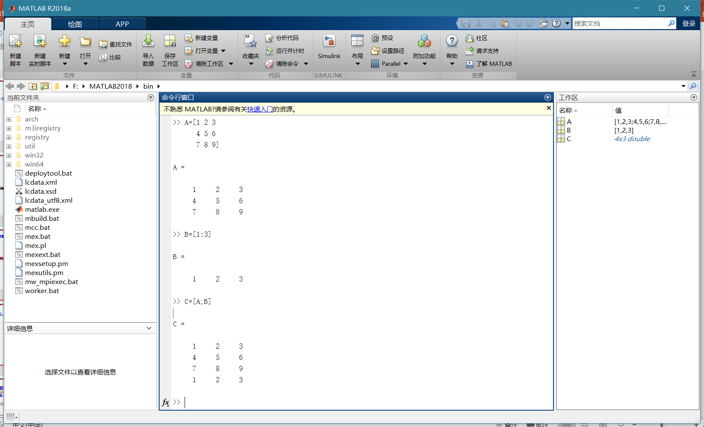

>> x=linspace(1,3,6)

x =

1.0000 1.4000 1.8000 2.2000 2.6000 3.0000

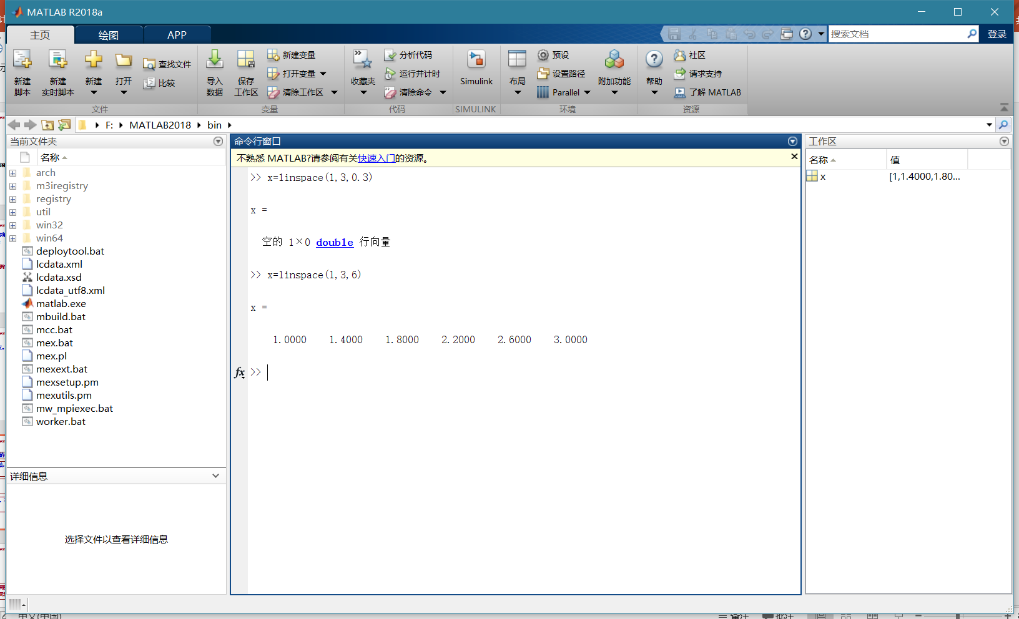

>> x=logspace(1,2,5)

x =

10.0000 17.7828 31.6228 56.2341 100.0000

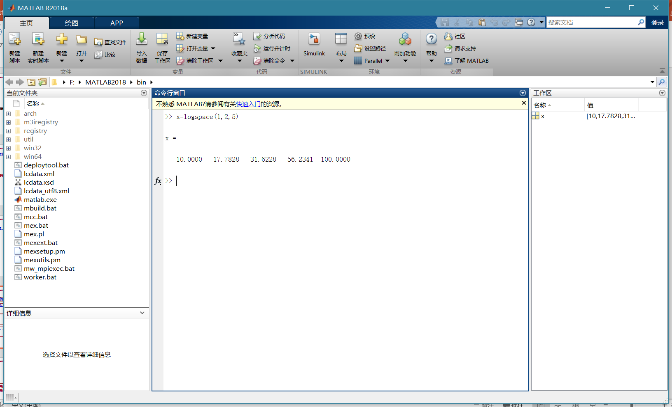

>> b=[ 1 2 3 4 ]

b =

1 2 3 4

>> c=b'

c =

1

2

3

4

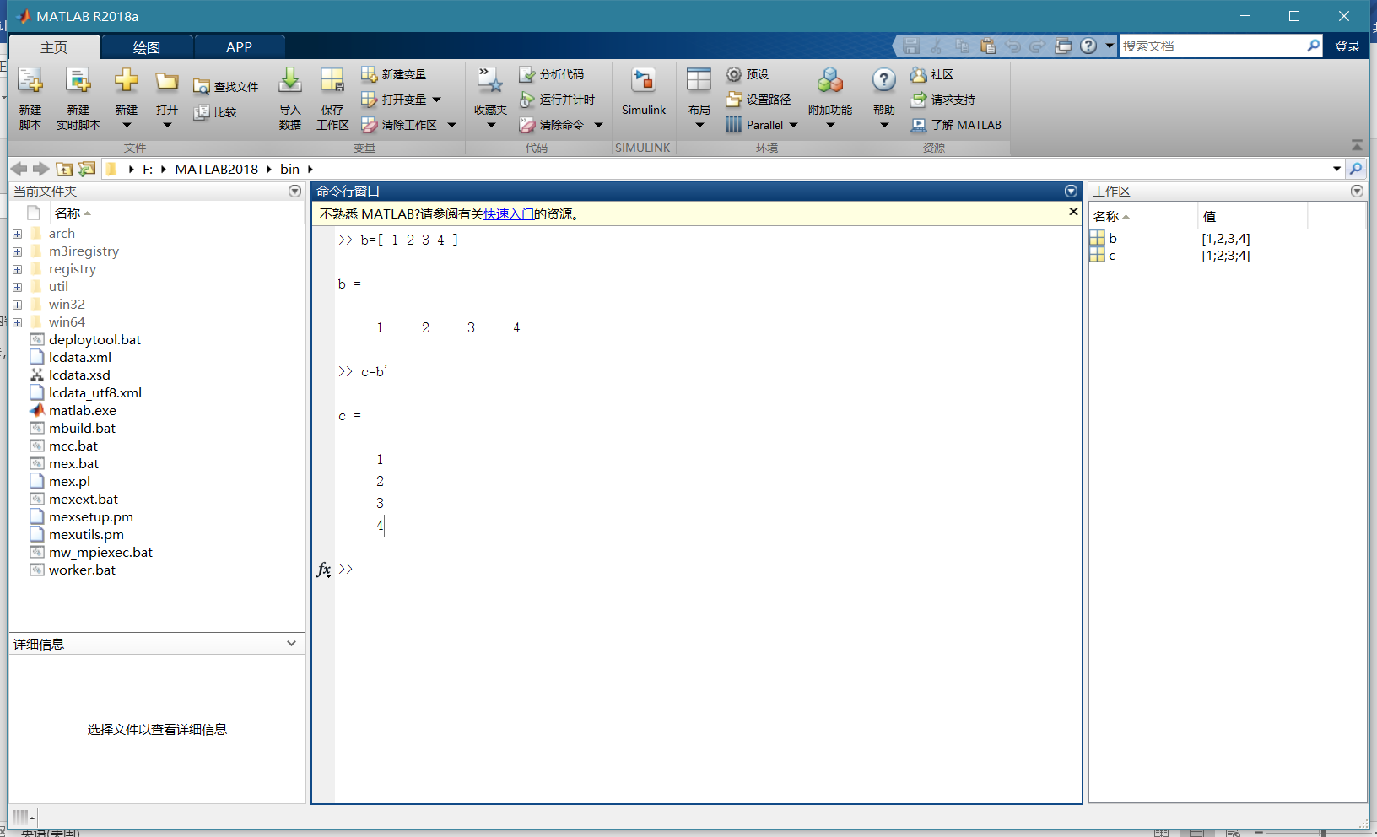

>> 2/3

ans =

0.6667

>> 3/2

ans =

1.5000

>> 3\2

ans =

0.6667

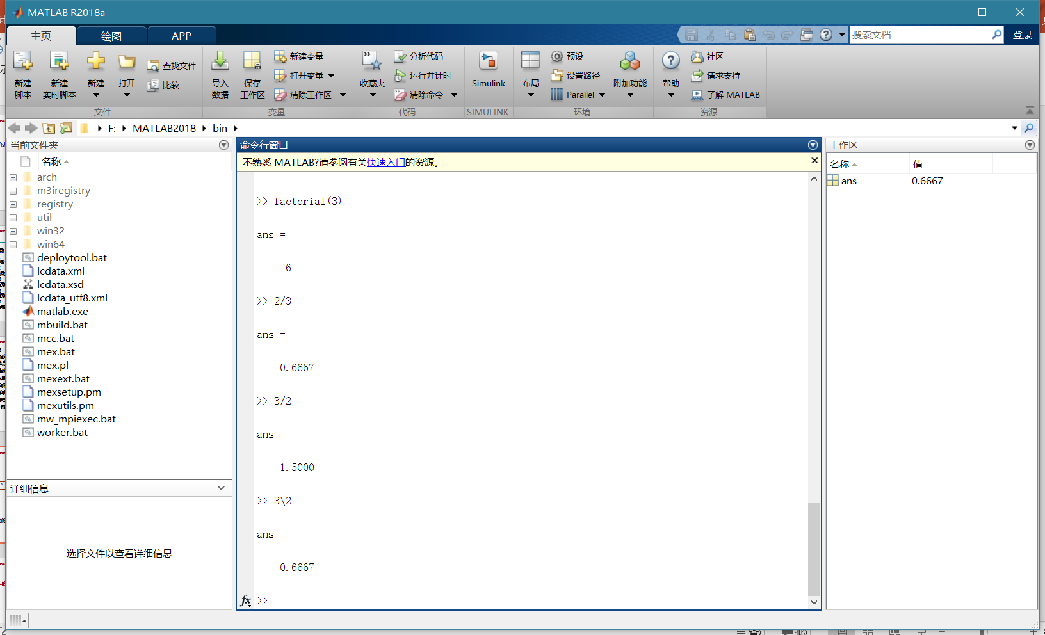

**对于矩阵**

**A/B:AB-1**

**A\B:A-1B**

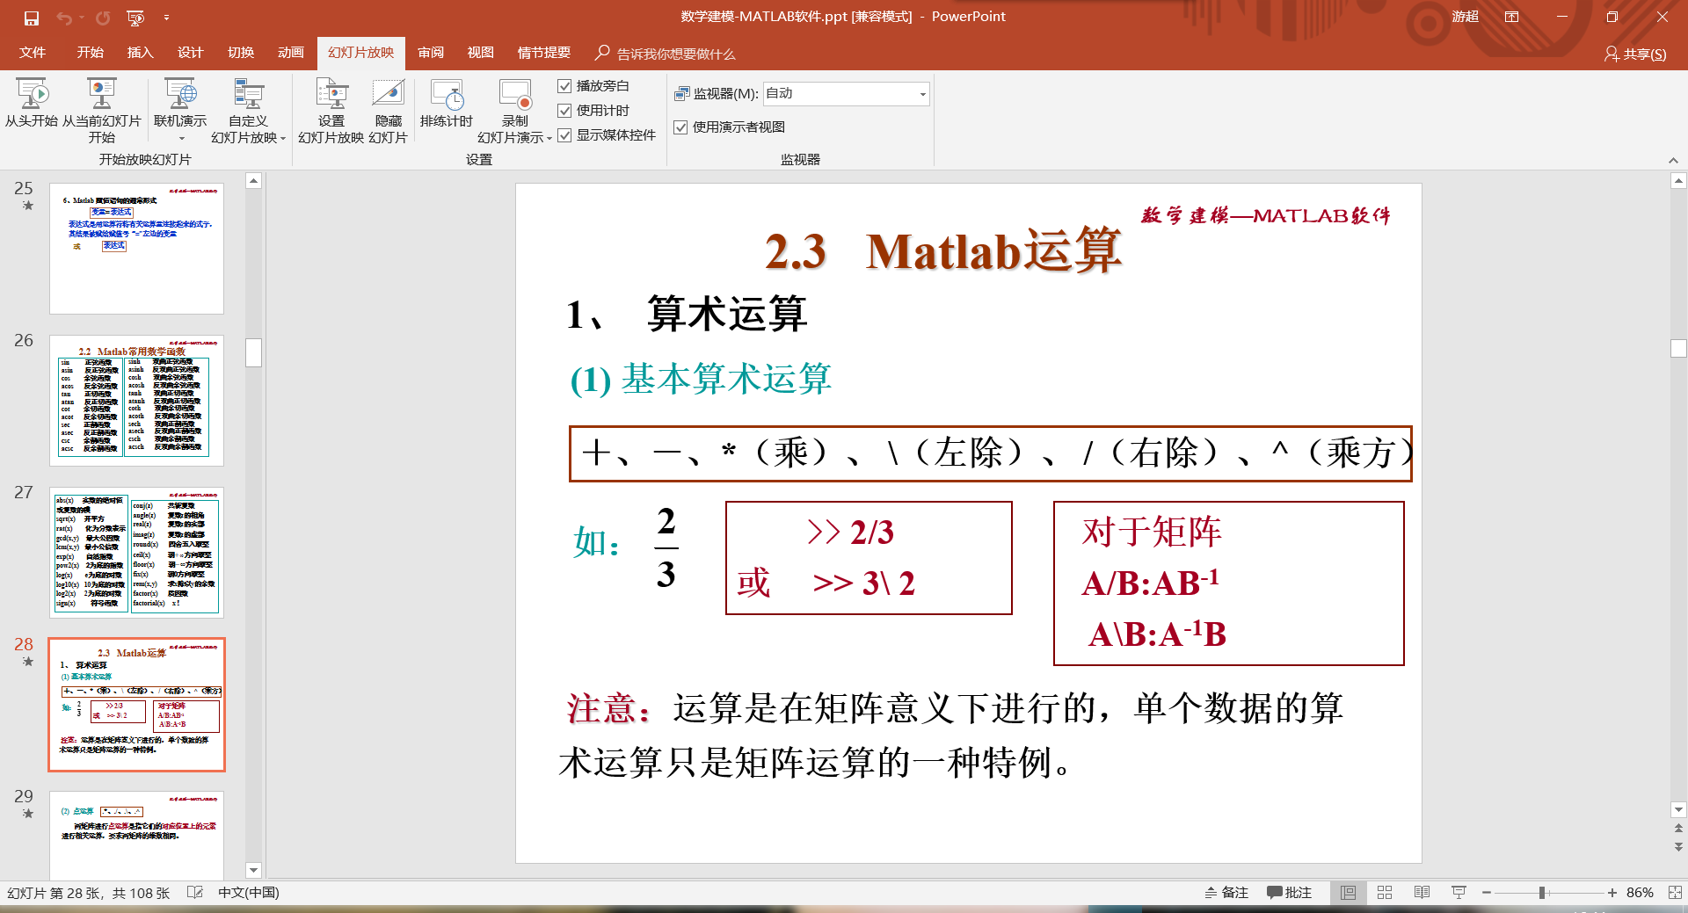

>> A=[1 2 3

4 5 6

7 8 9]

A =

1 2 3

4 5 6

7 8 9

>> B=[2 3 4

4 5 6

1 2 3]

B =

2 3 4

4 5 6

1 2 3

>> A<=B

ans =

3×3 logical 数组

1 1 1

1 1 1

0 0 0

>> A~=B

ans =

3×3 logical 数组

1 1 1

0 0 0

1 1 1

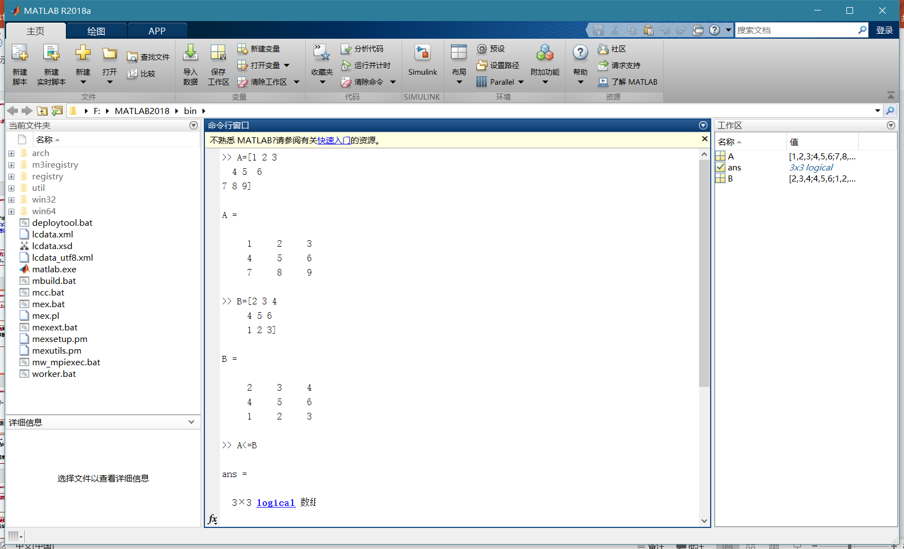

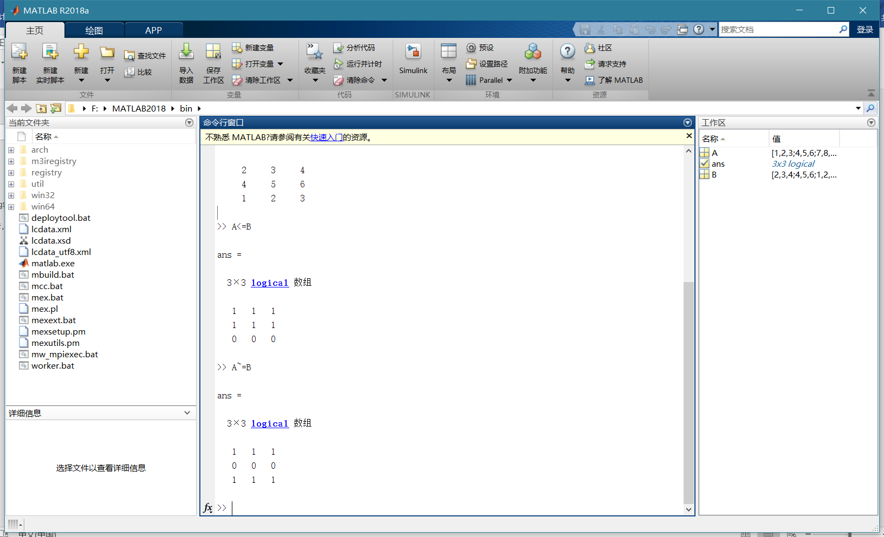

>> C=2

C =

2

>> A==C

ans =

3×3 logical 数组

0 1 0

0 0 0

0 0 0

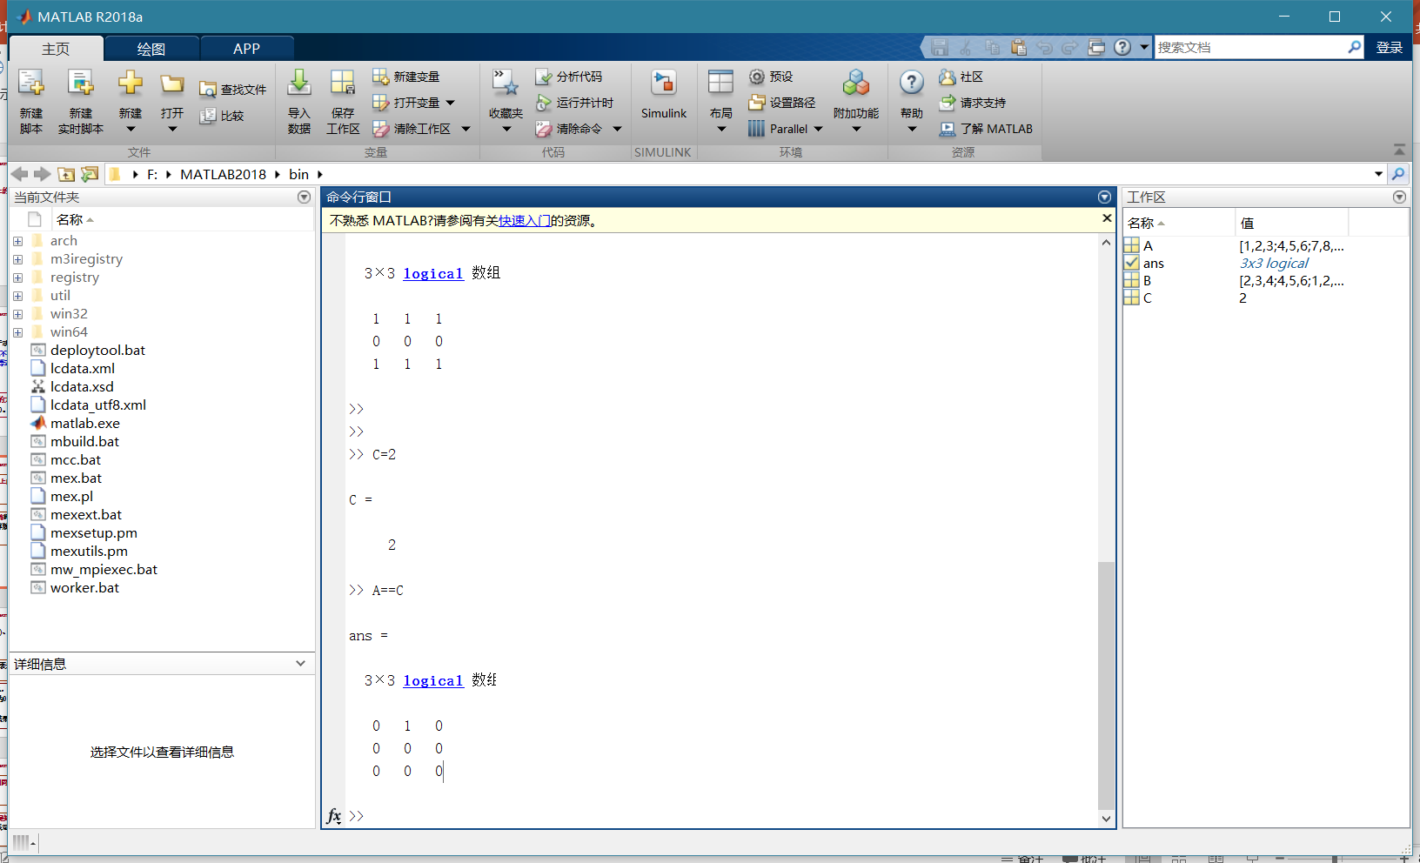

>> A=[1 0 1;1 1 0;0 1 1]

A =

1 0 1

1 1 0

0 1 1

>> B=1

B =

1

>> A&B

ans =

3×3 logical 数组

1 0 1

1 1 0

0 1 1

>> A|B

ans =

3×3 logical 数组

1 1 1

1 1 1

1 1 1

>> ~B

ans =

logical

0

>> ~A

ans =

3×3 logical 数组

0 1 0

0 0 1

1 0 0

>> C=[0 0 1;1 1 0;0 1 0]

C =

0 0 1

1 1 0

0 1 0

>> A&C

ans =

3×3 logical 数组

0 0 1

1 1 0

0 1 0

>> A|C

ans =

3×3 logical 数组

1 0 1

1 1 0

0 1 1

>> ~C

ans =

3×3 logical 数组

1 1 0

0 0 1

1 0 1

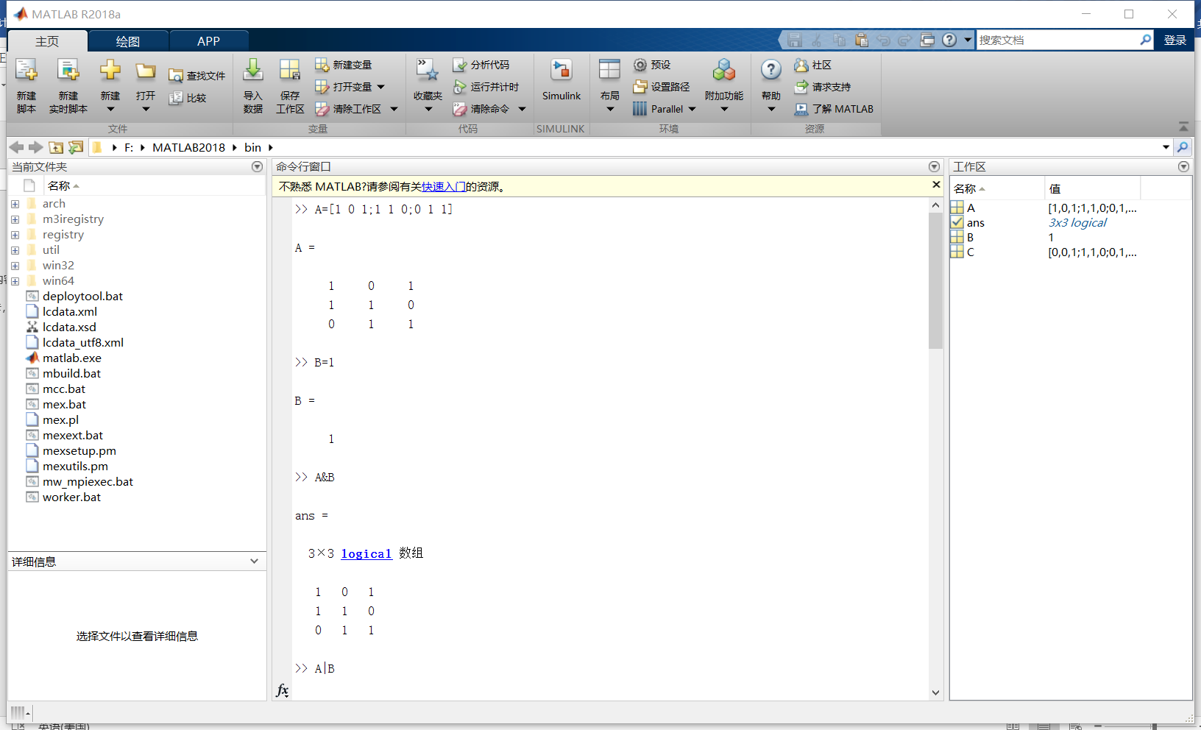

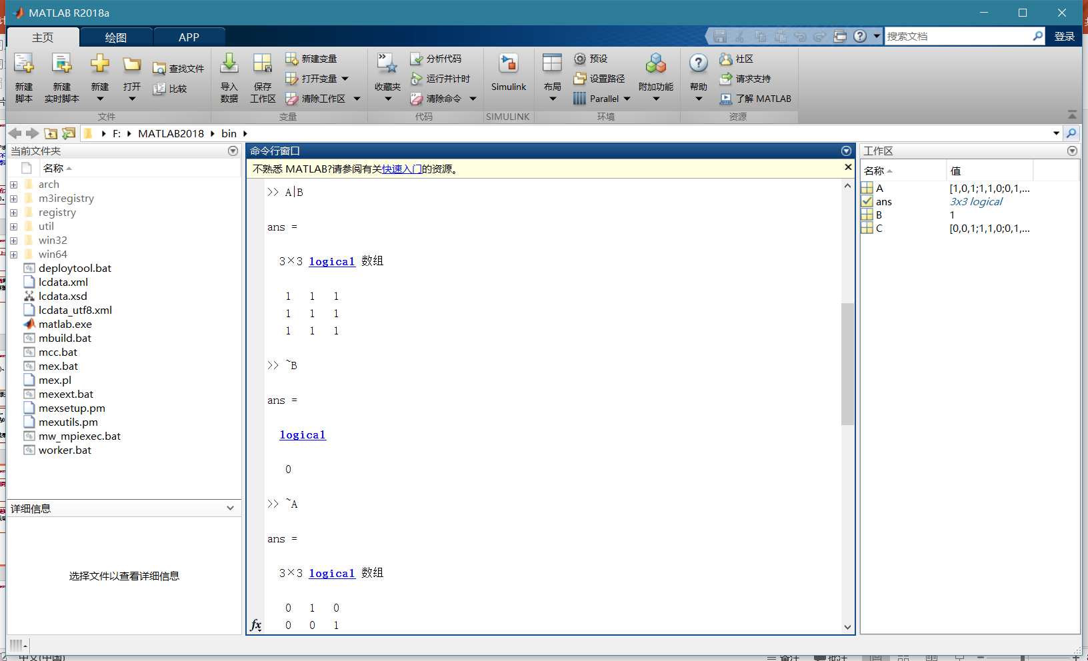

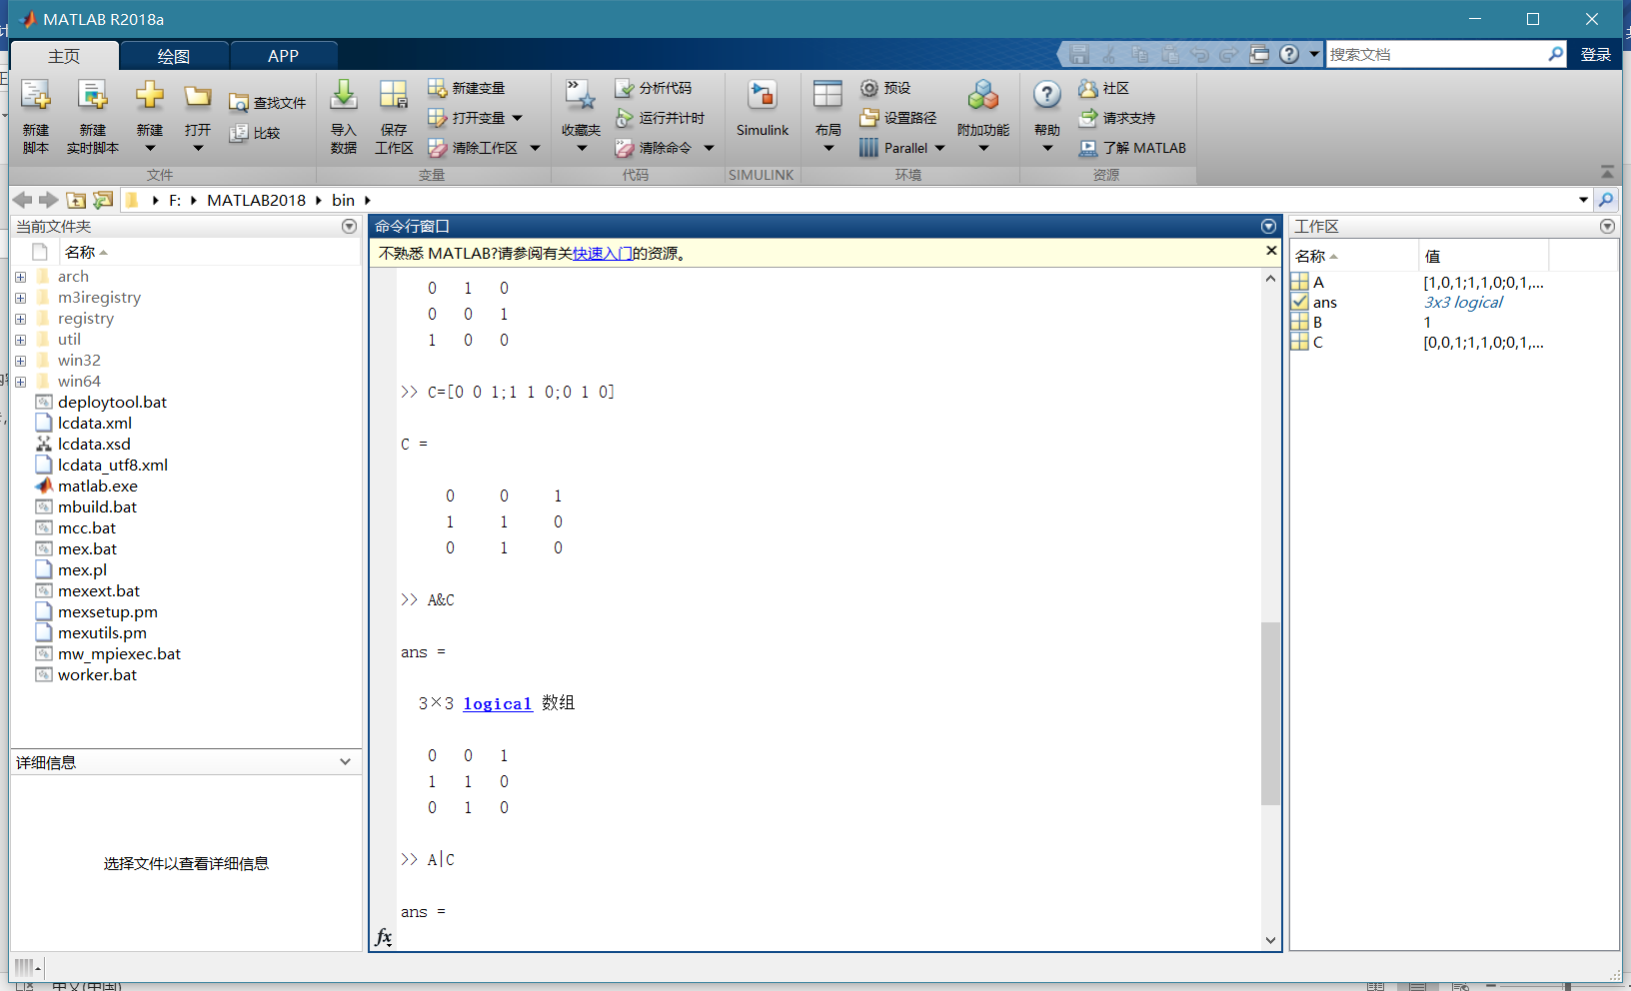

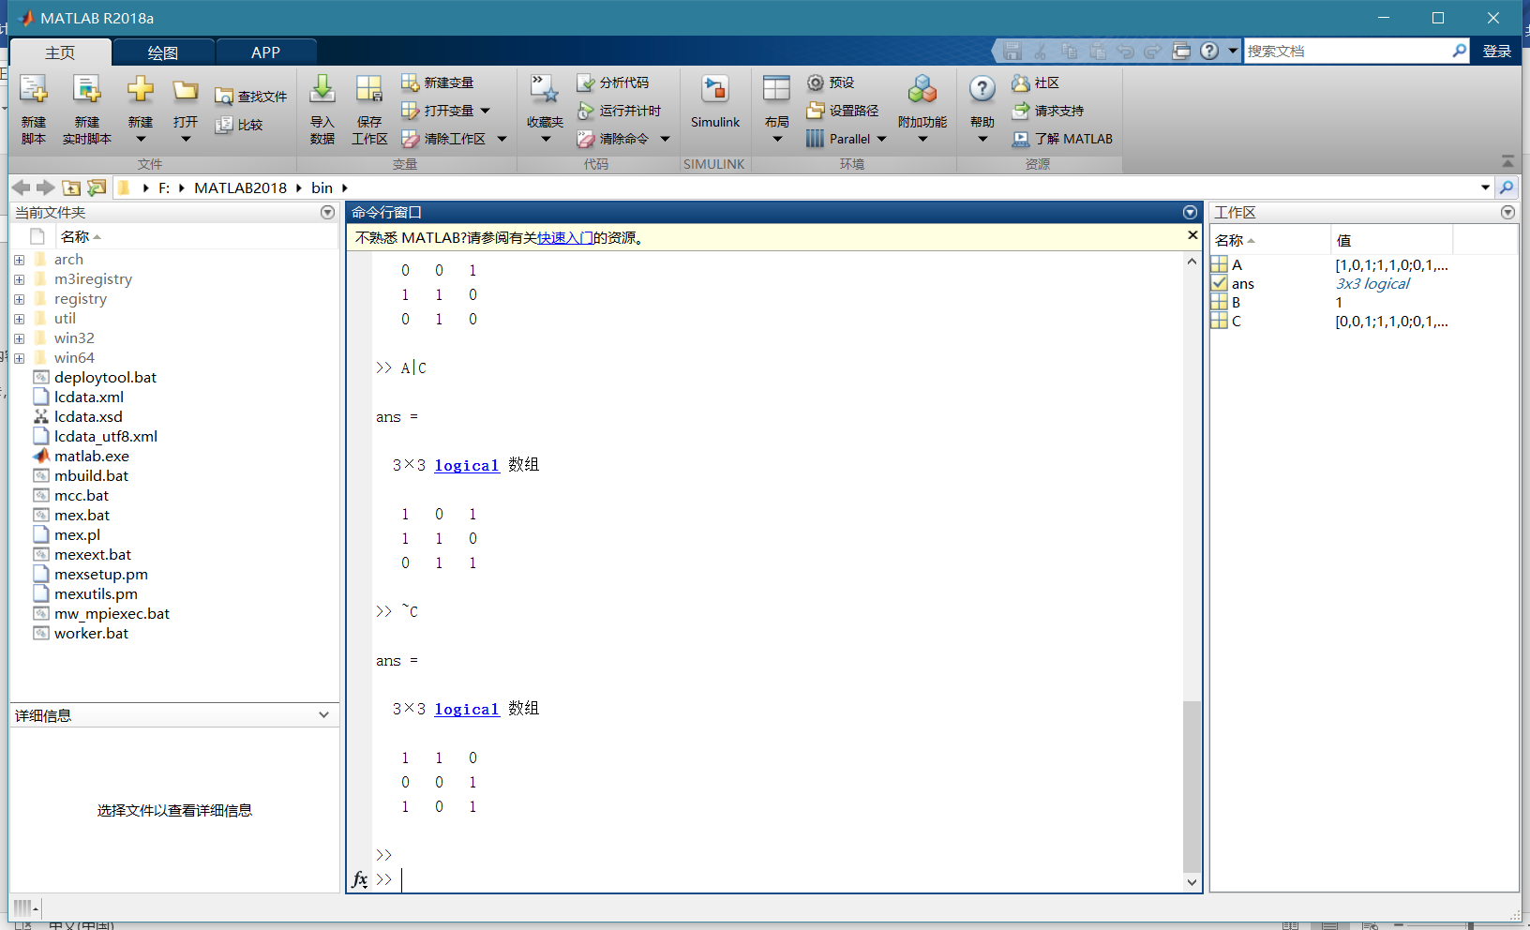

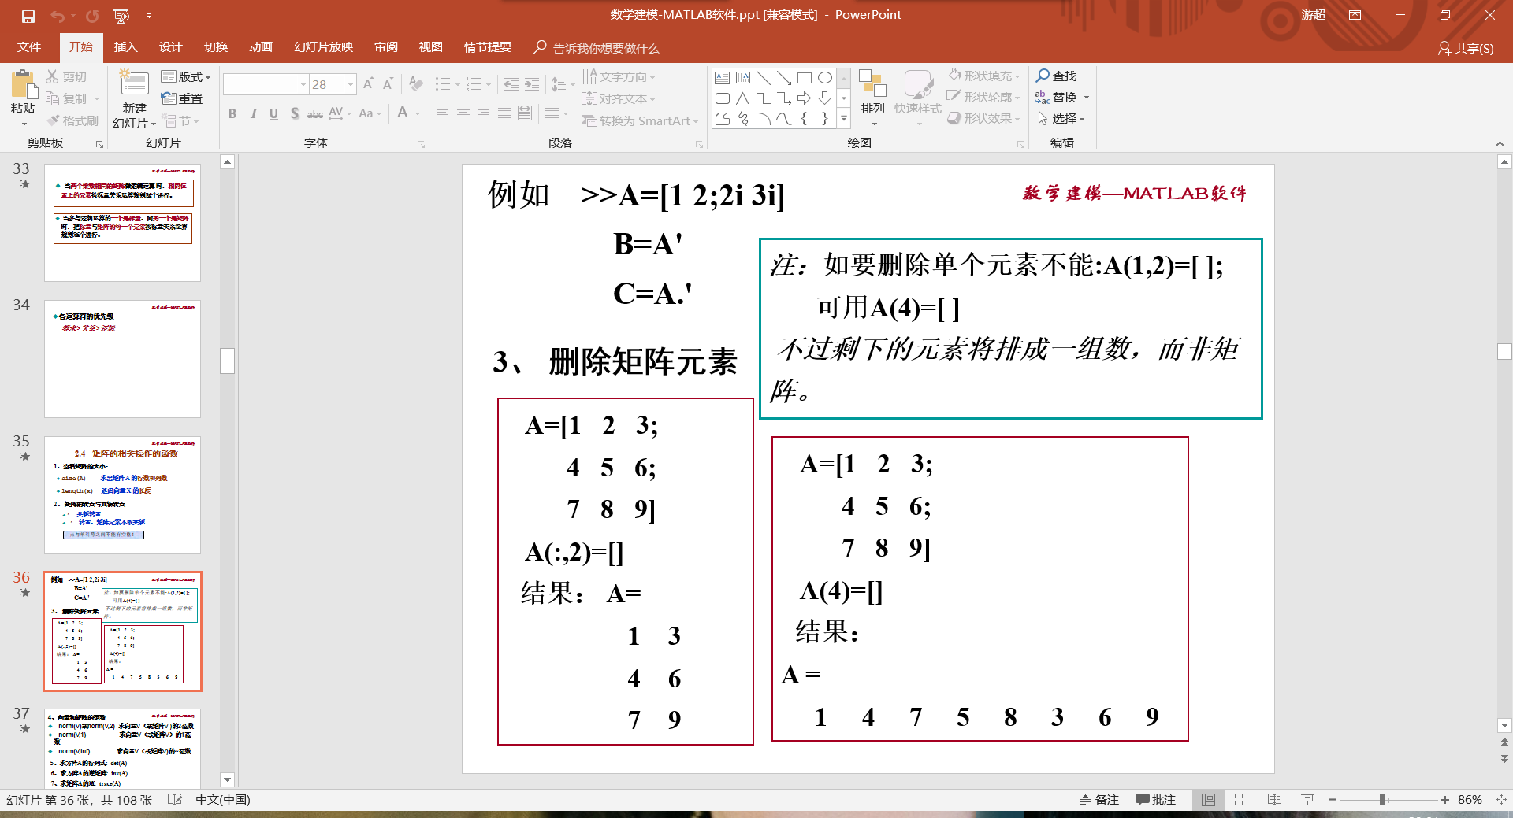

>> A=[1 2;2i 3i]

A =

1.0000 + 0.0000i 2.0000 + 0.0000i

0.0000 + 2.0000i 0.0000 + 3.0000i

>> B=A'

B =

1.0000 + 0.0000i 0.0000 - 2.0000i

2.0000 + 0.0000i 0.0000 - 3.0000i

>> C=A.'

C =

1.0000 + 0.0000i 0.0000 + 2.0000i

2.0000 + 0.0000i 0.0000 + 3.0000i

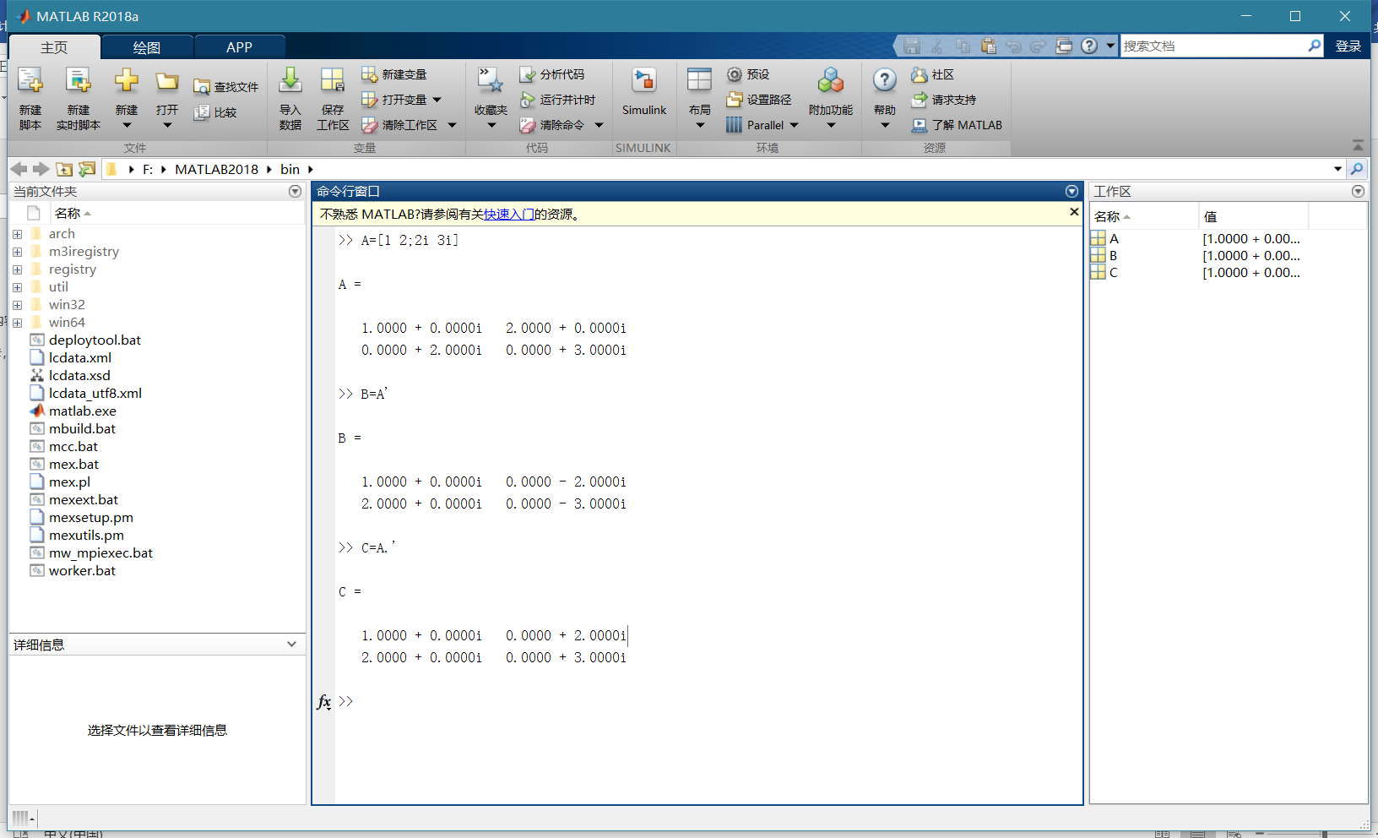

>> A=[1 2 3;4 5 6;7 8 9]

A =

1 2 3

4 5 6

7 8 9

>> A(:,2)=[]

A =

1 3

4 6

7 9

>> A(1,2)=[]

空赋值只能具有一个非冒号索引。

>> A(4)=[]

A =

1 4 7 6 9

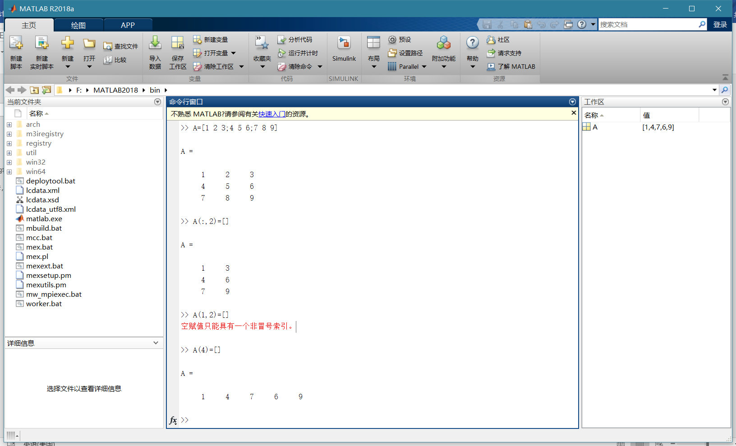

>> A=[1,2,3;4, ,6]

A=[1,2,3;4, ,6]

↑

错误: 表达式无效。调用函数或对变量进行索引时，请使用圆括号。否则，请检查不匹配的分隔符。

>> A=[1,2,3;4,' ',6]

A =

2×3 char 数组

''

' '

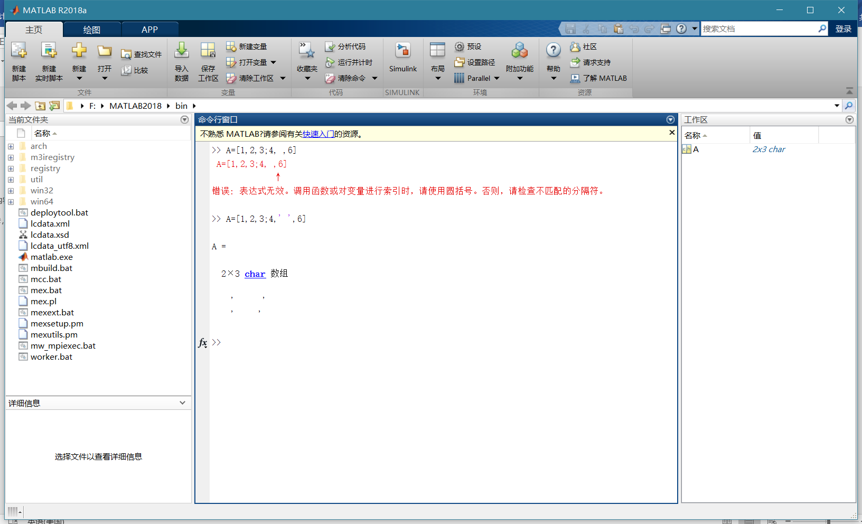

所以赋空值不存在的

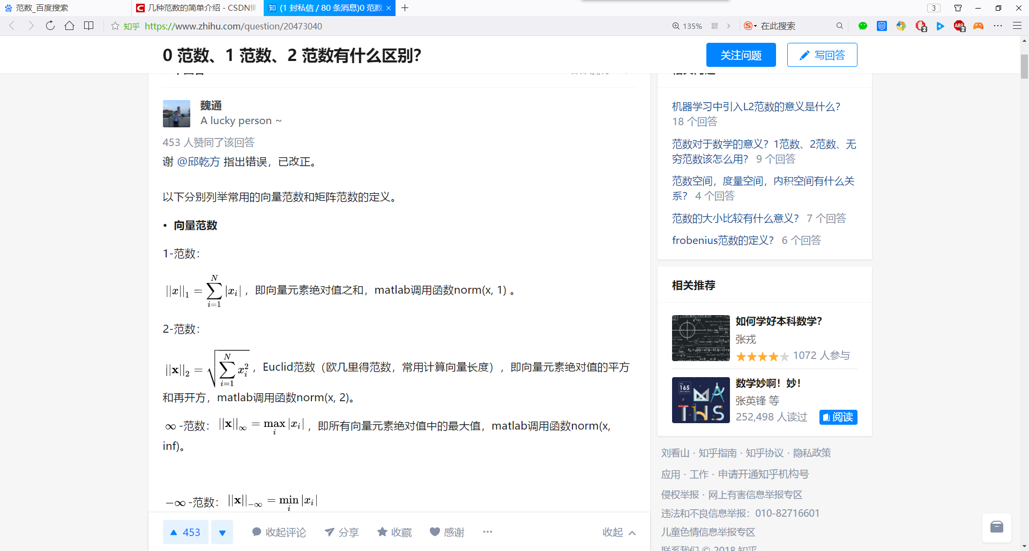

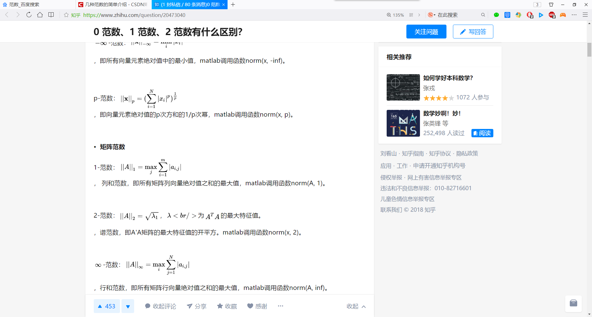

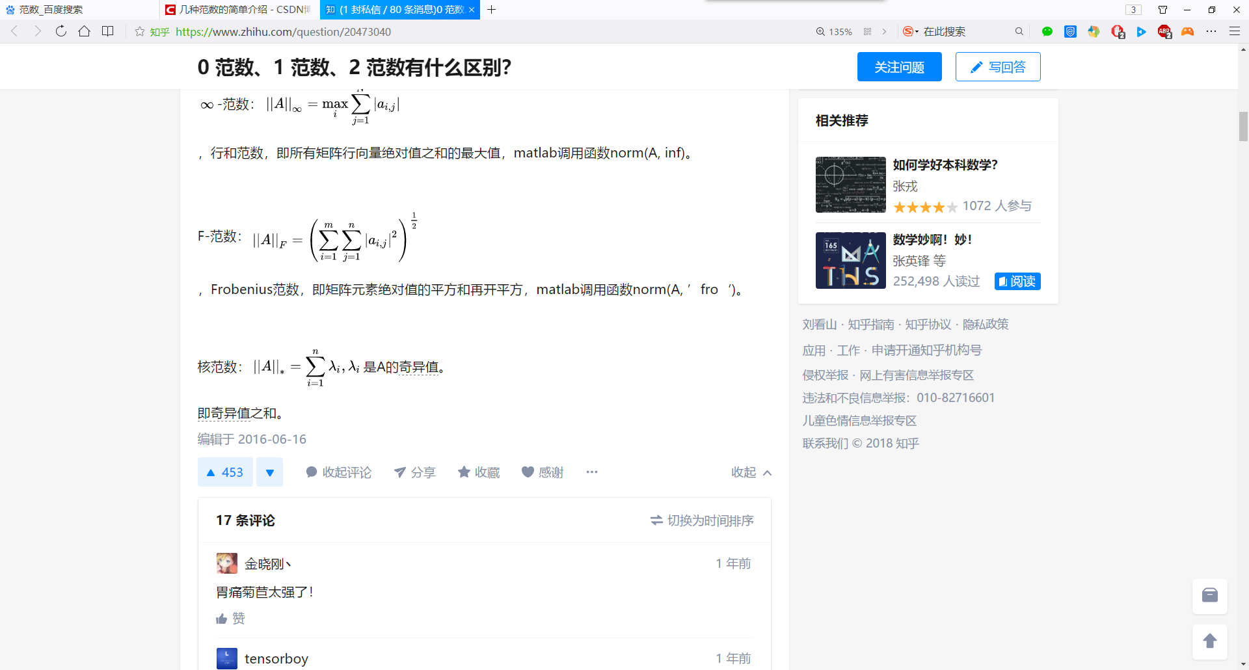

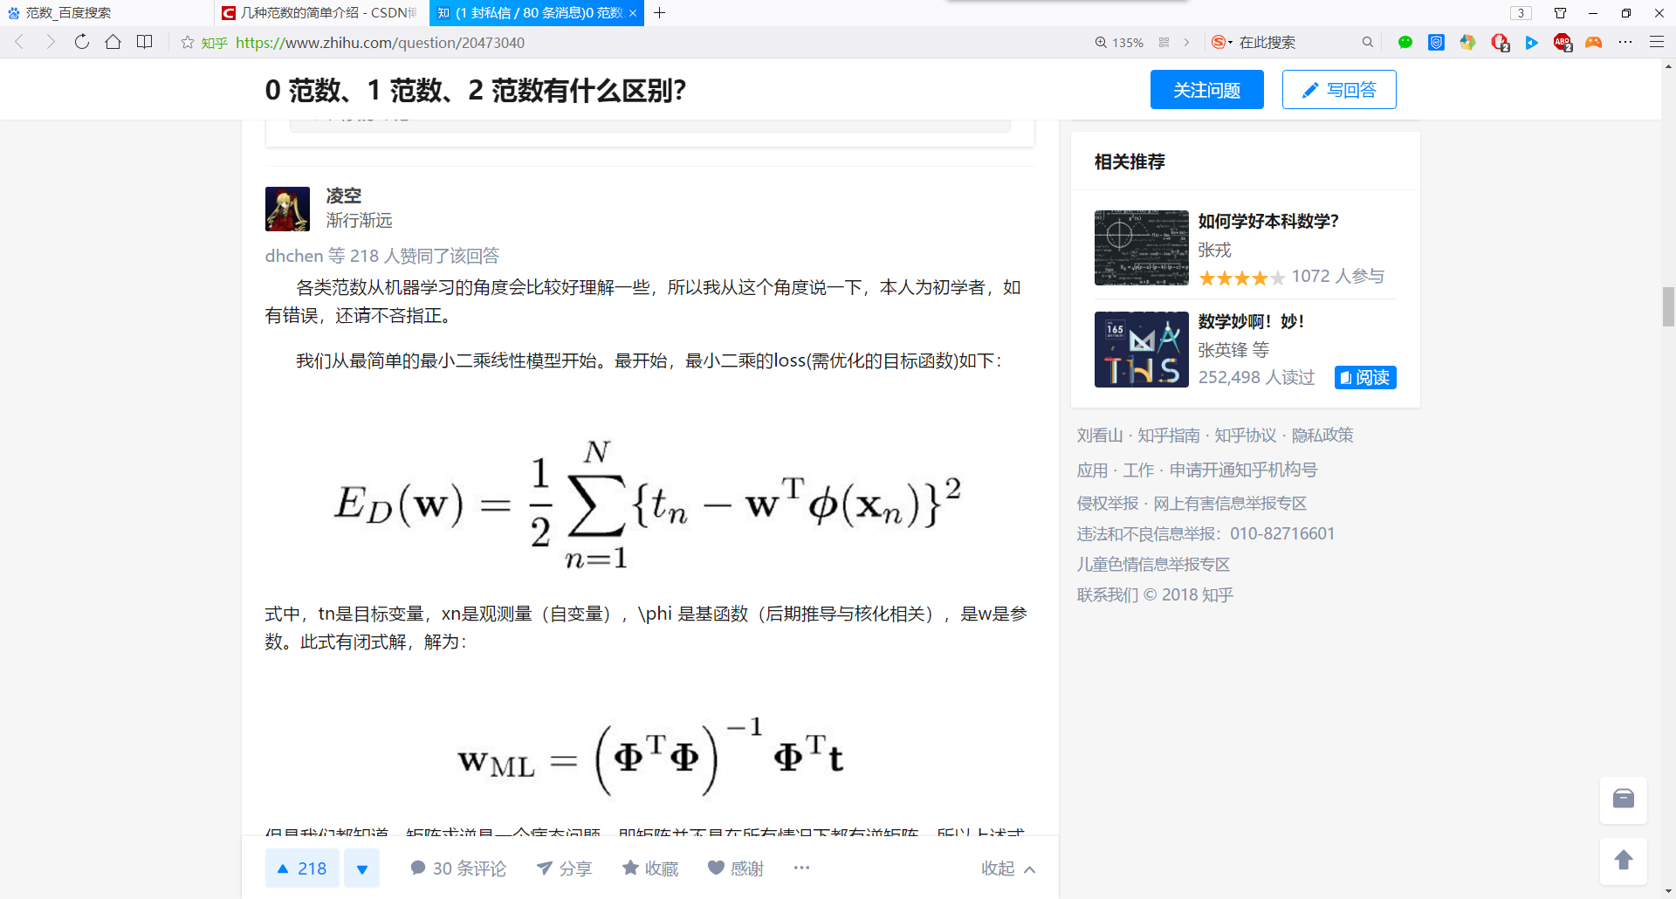

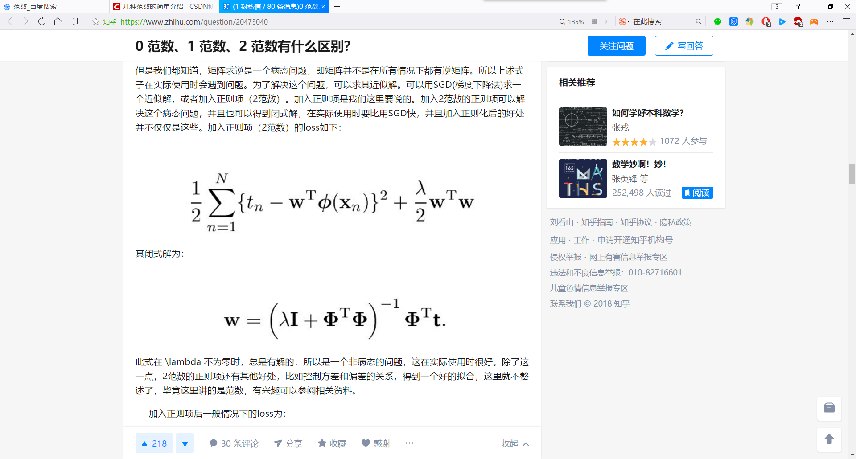

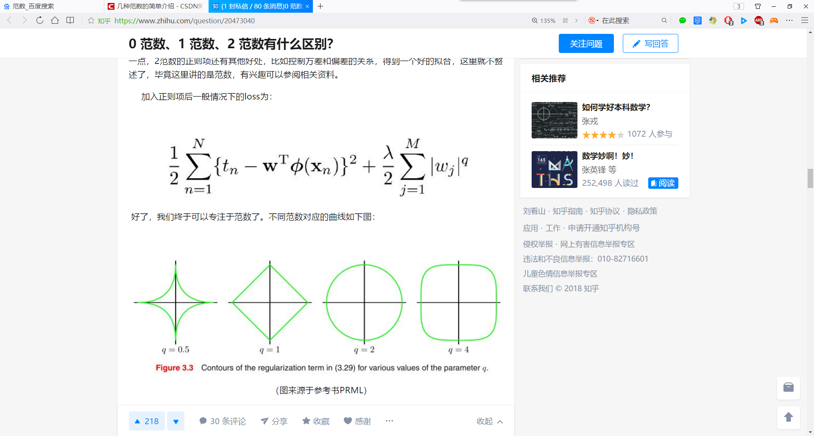

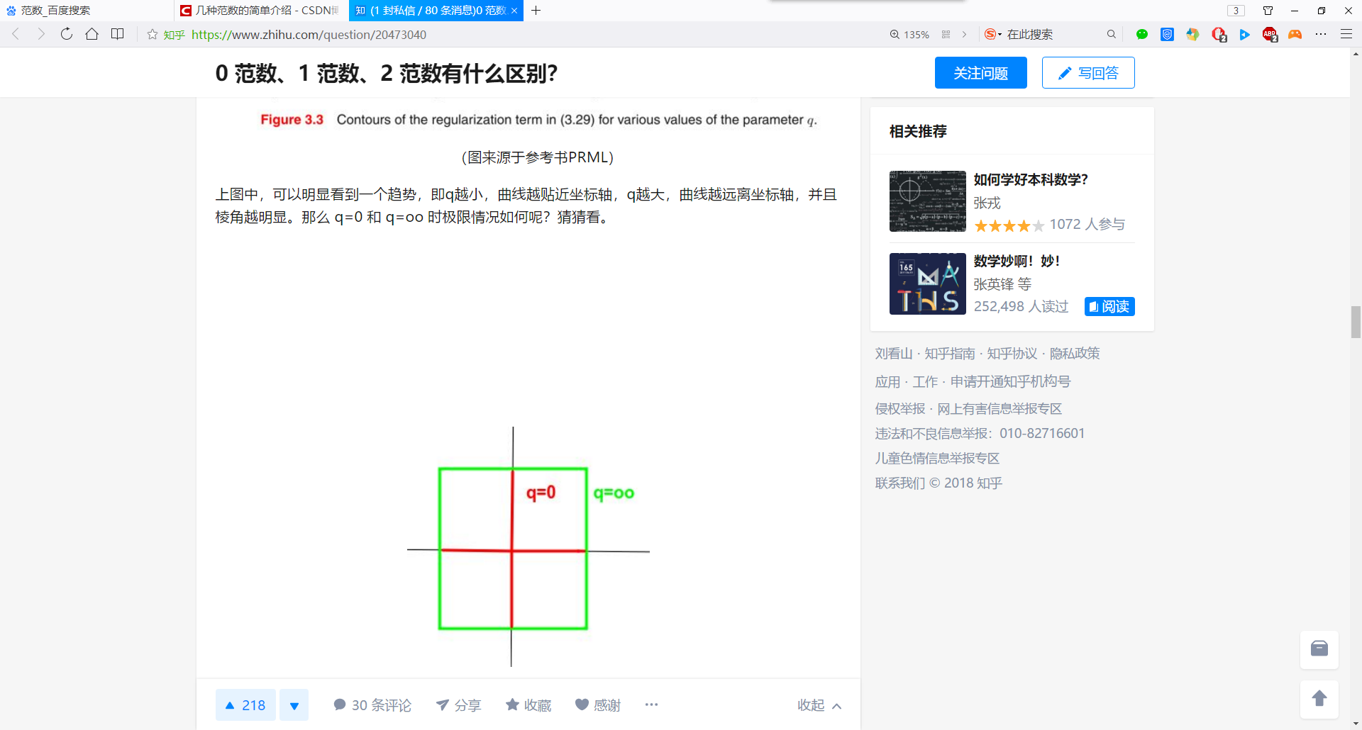

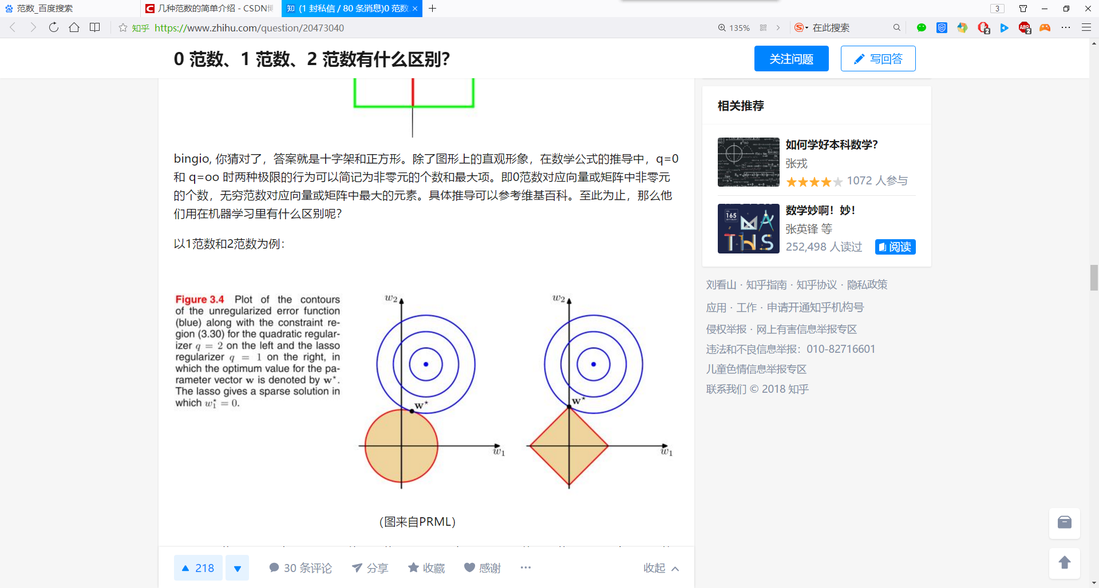

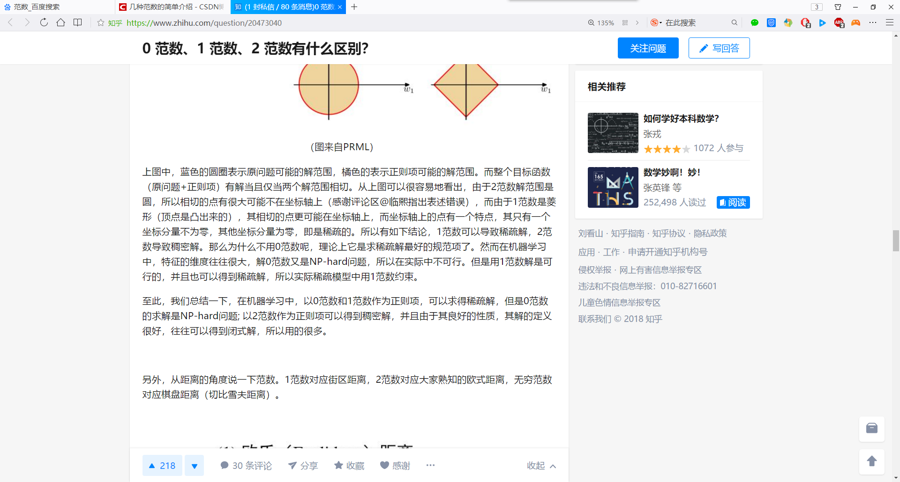

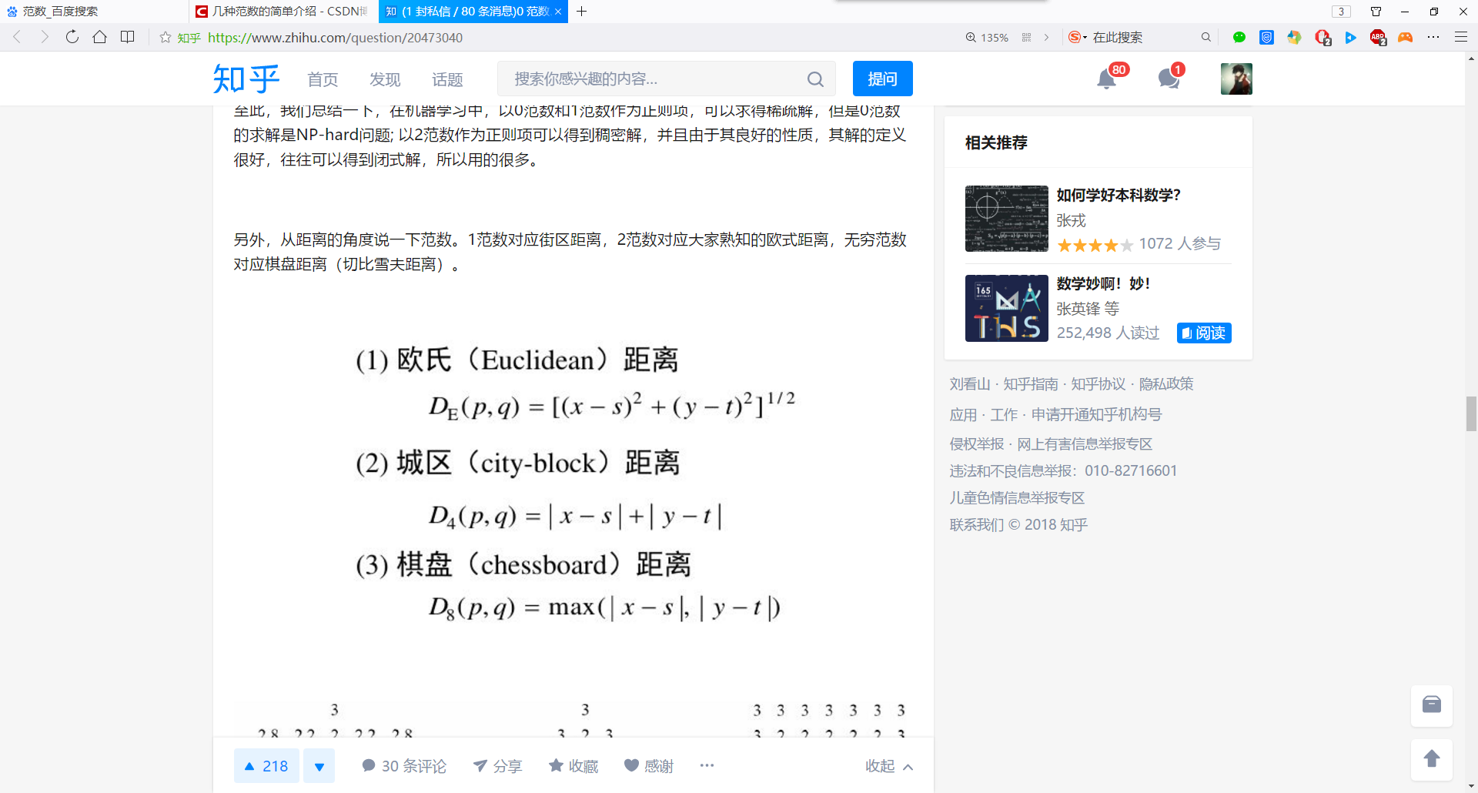

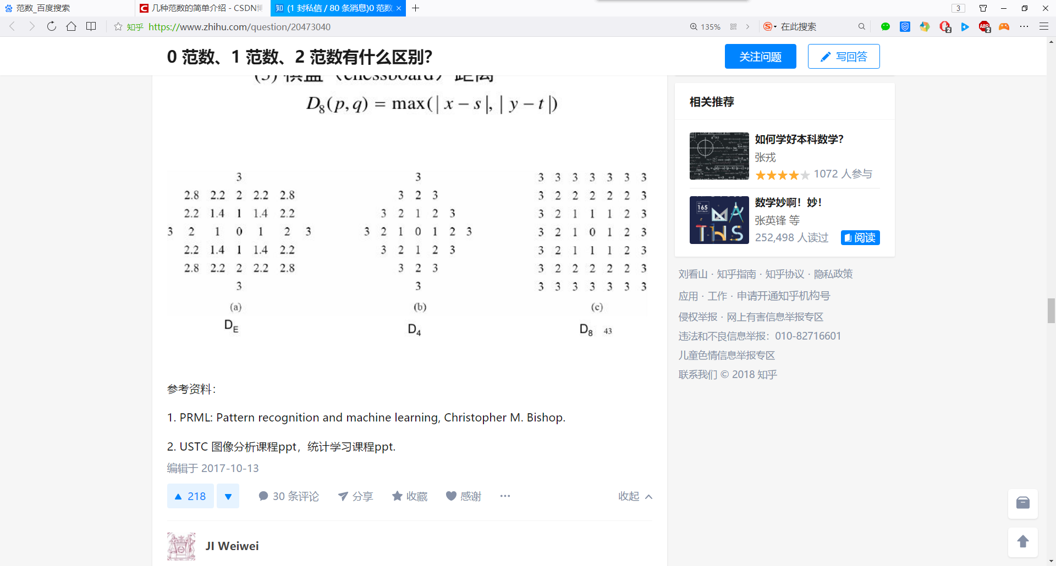

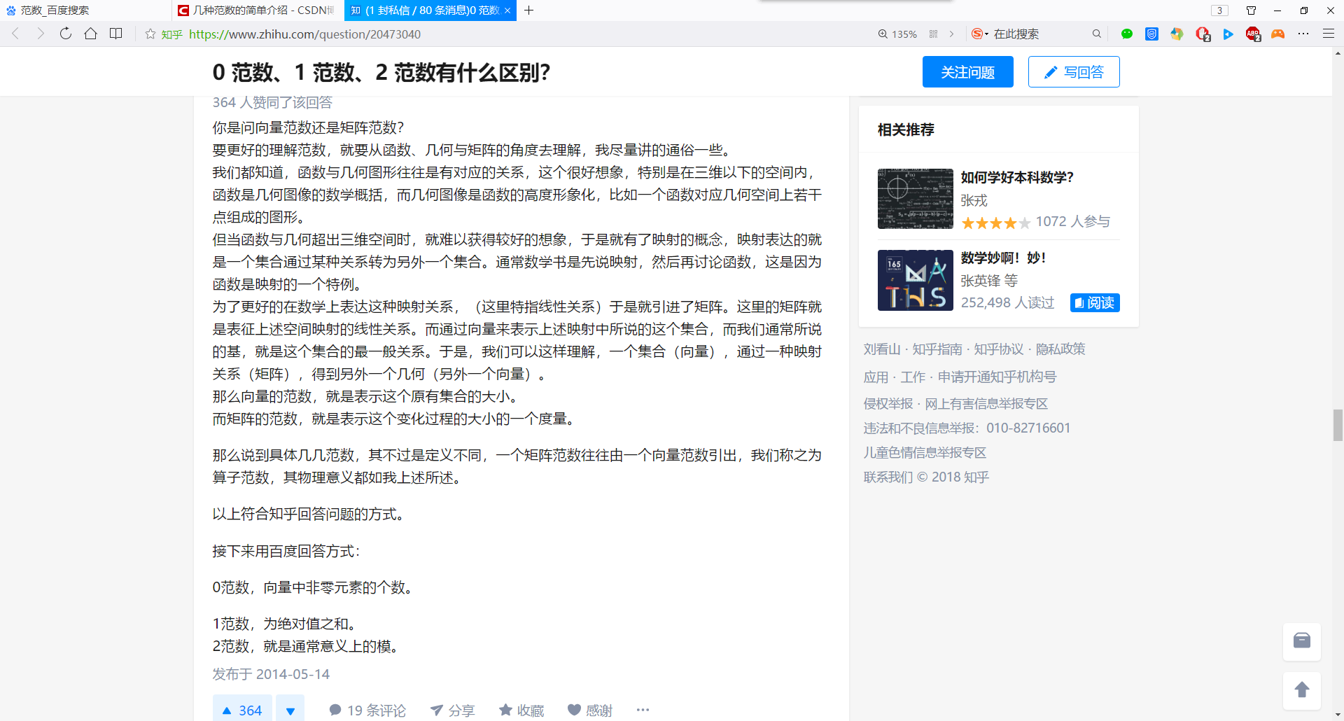

>> A=[1,2,-4;-2,2,1;-3,4,-2]

A =

1 2 -4

-2 2 1

-3 4 -2

>> det(A)

ans =

-14.0000

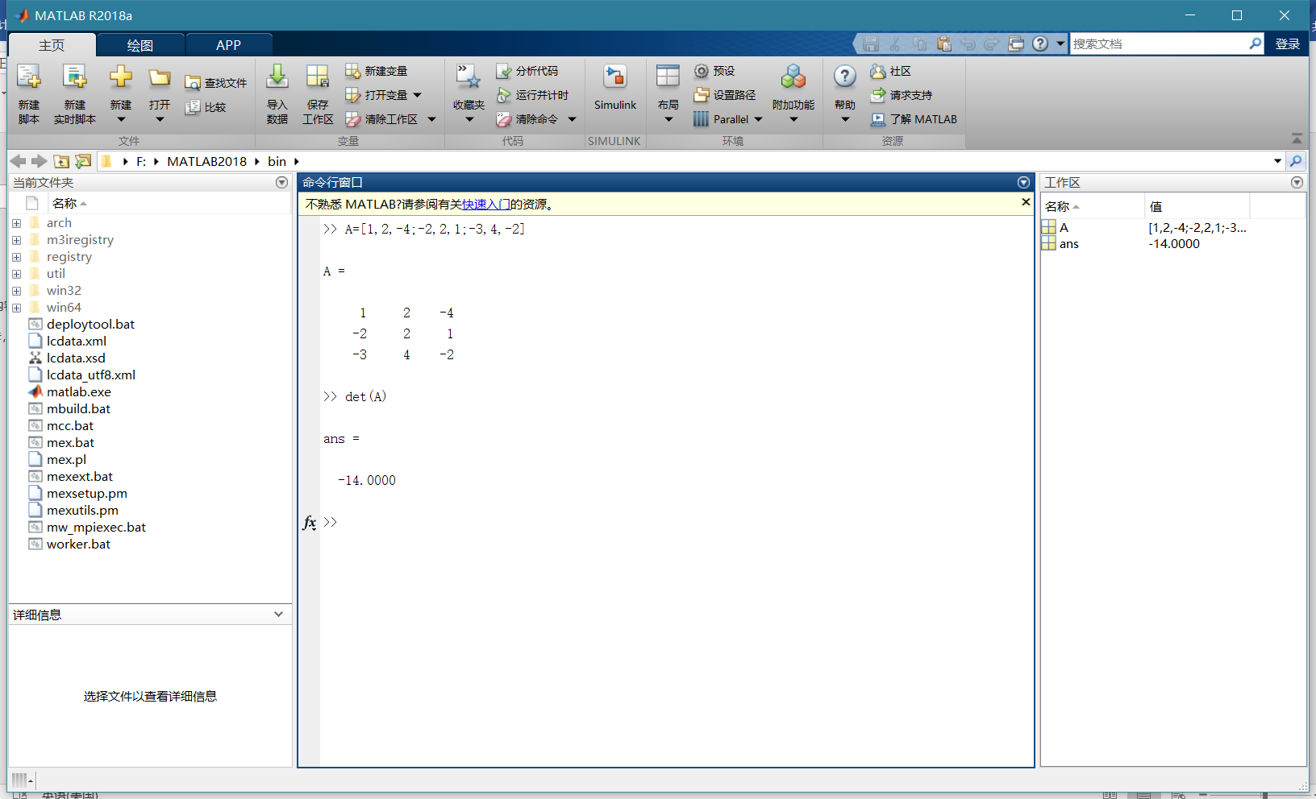

>> A=[1 2 3;2 2 1;3 4 3]

A =

1 2 3

2 2 1

3 4 3

>> B=inv(A)

B =

1.0000 3.0000 -2.0000

-1.5000 -3.0000 2.5000

1.0000 1.0000 -1.0000

>> A*B

ans =

1.0000 0.0000 0

-0.0000 1.0000 0.0000

-0.0000 0.0000 1.0000

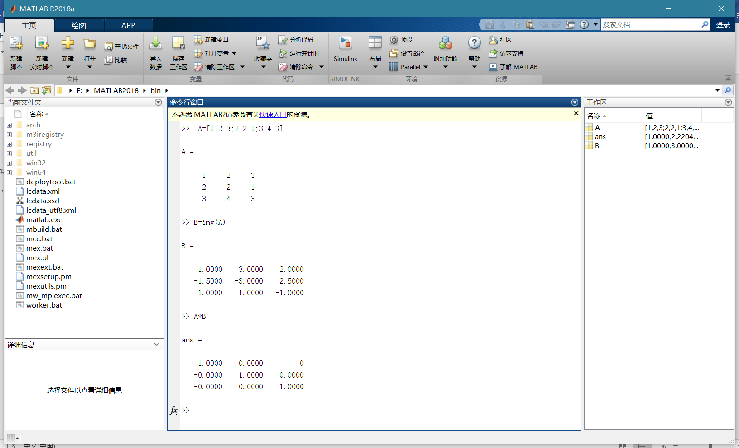

>> trace(A)

ans =

6

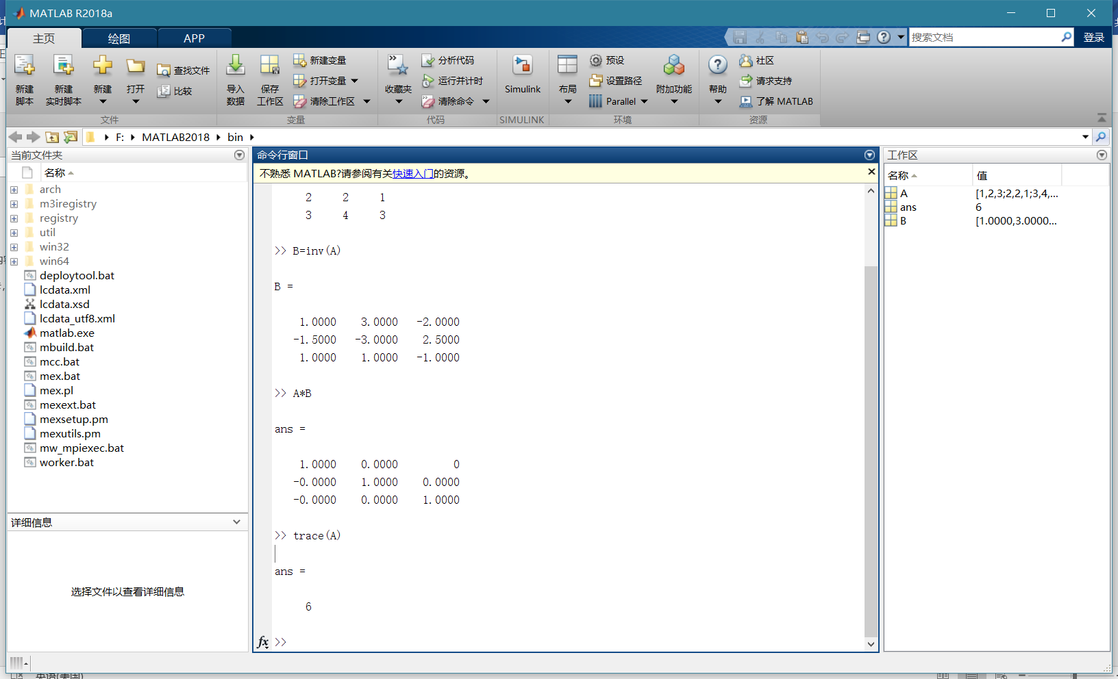

>> rank(A)

ans =

3

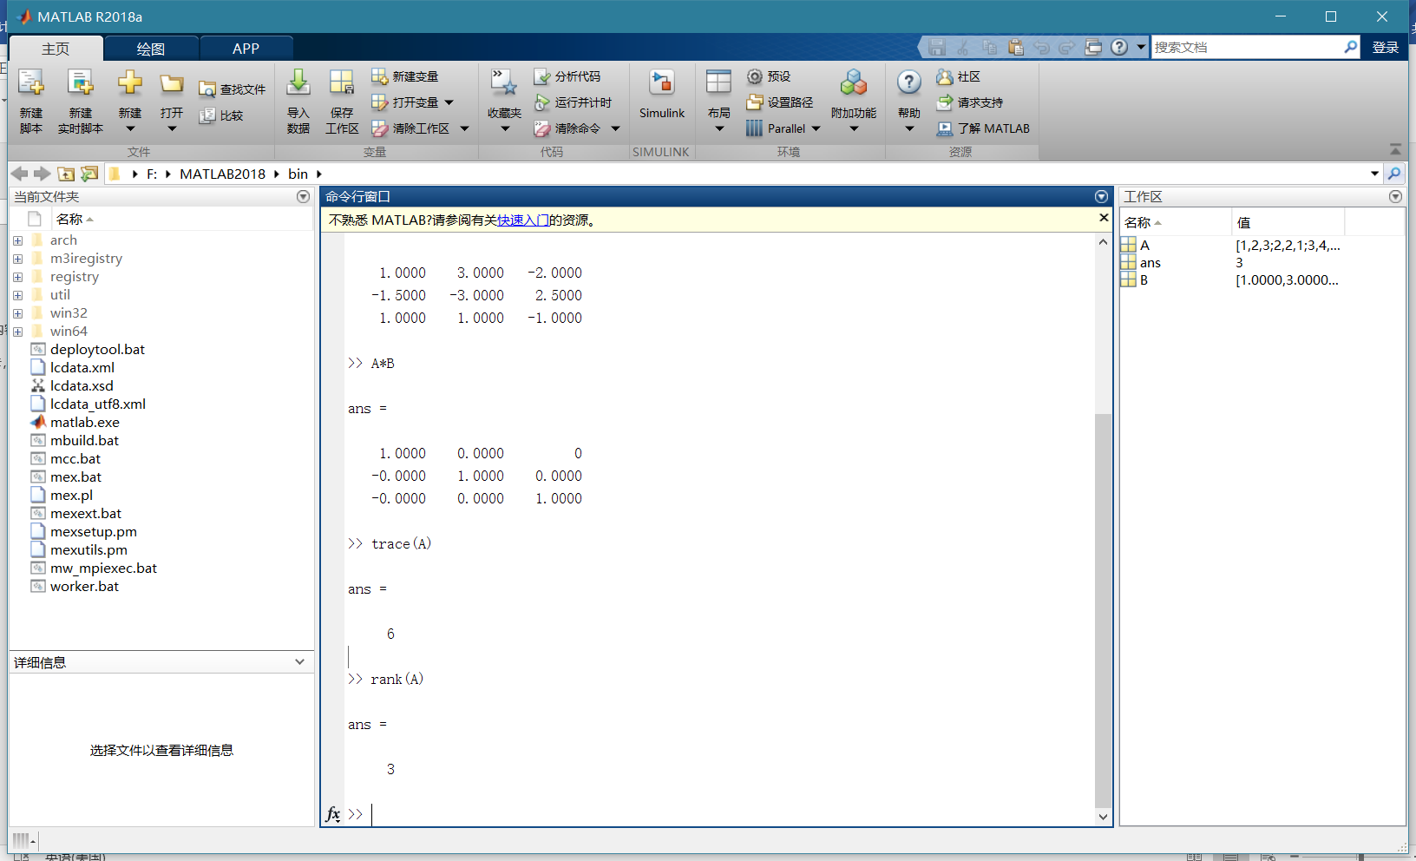

>> d=eig(A)

d =

6.9102 + 0.0000i

-0.4551 + 0.2869i

-0.4551 - 0.2869i

>> [V,D]=eig(A)

V =

0.5169 + 0.0000i 0.7551 + 0.0000i 0.7551 + 0.0000i

0.3679 + 0.0000i -0.6173 - 0.1394i -0.6173 + 0.1394i

0.7730 + 0.0000i 0.0453 + 0.1652i 0.0453 - 0.1652i

D =

6.9102 + 0.0000i 0.0000 + 0.0000i 0.0000 + 0.0000i

0.0000 + 0.0000i -0.4551 + 0.2869i 0.0000 + 0.0000i

0.0000 + 0.0000i 0.0000 + 0.0000i -0.4551 - 0.2869i

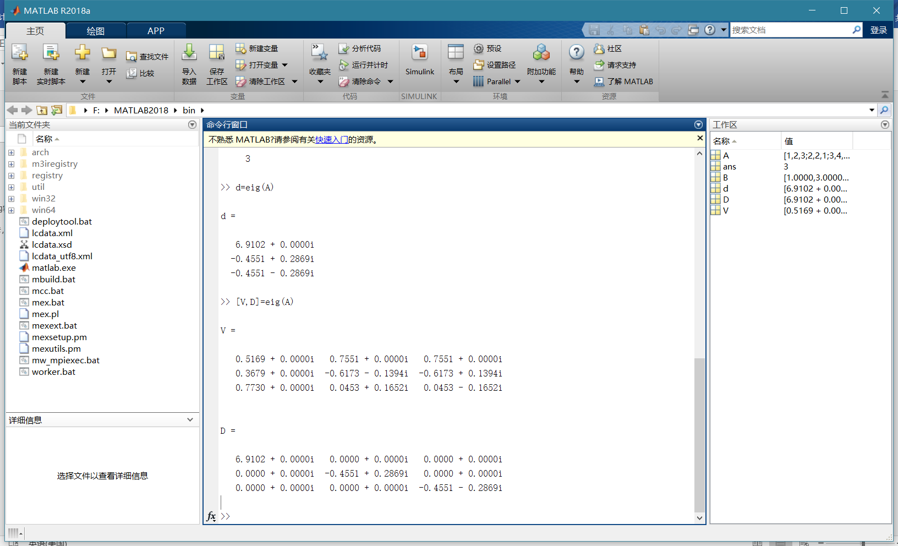

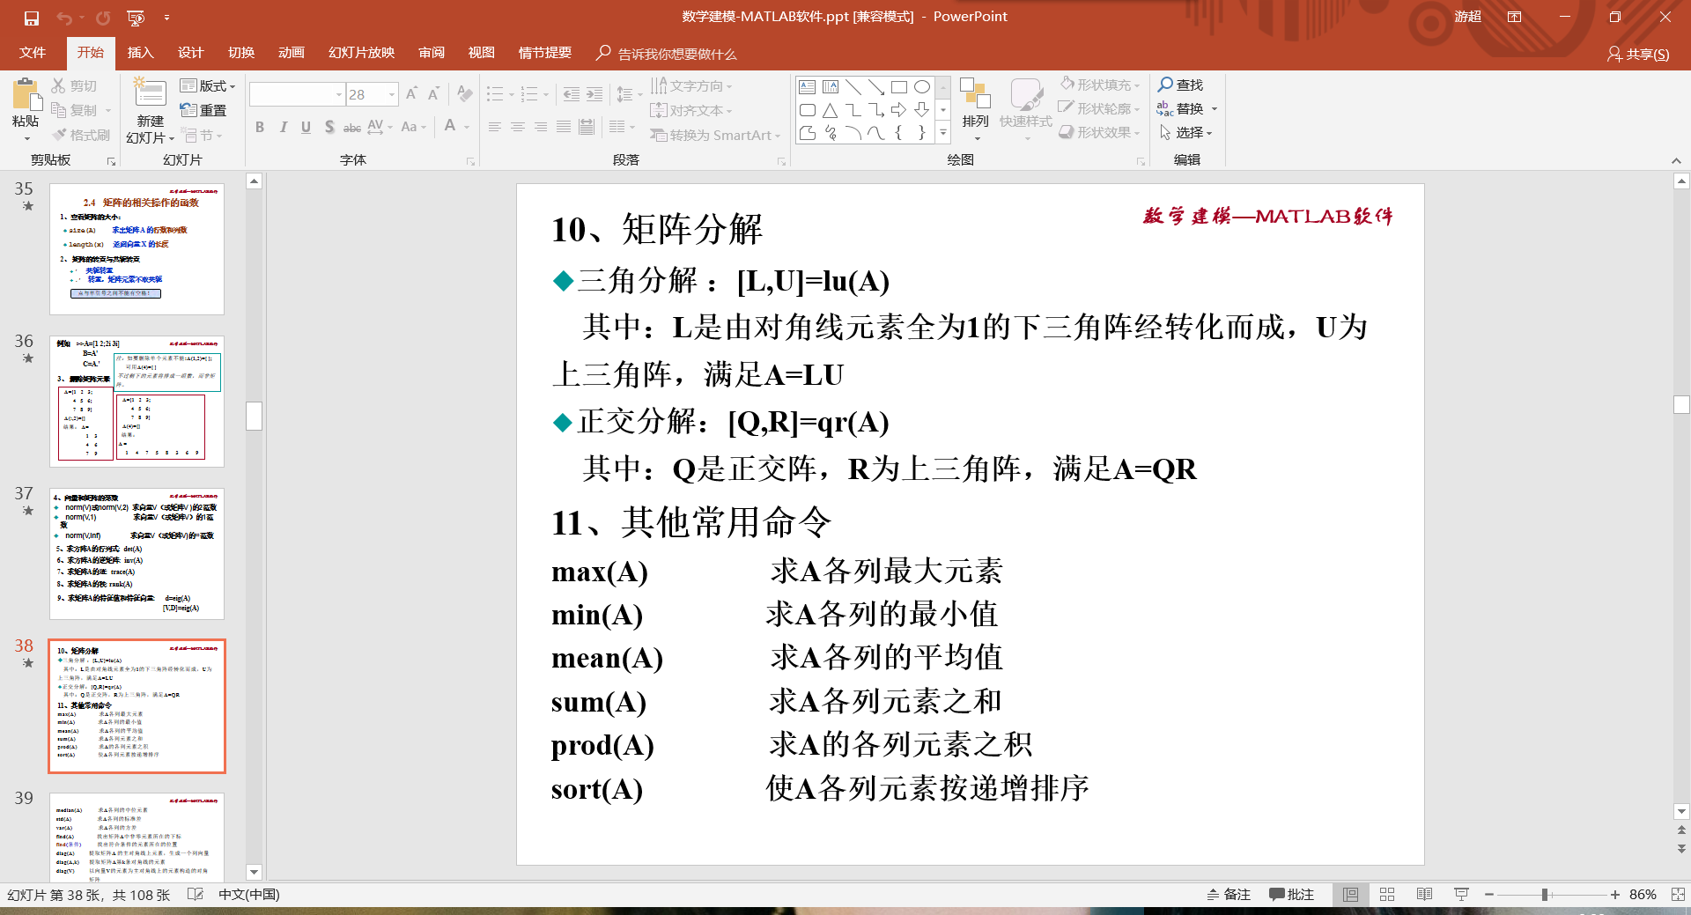

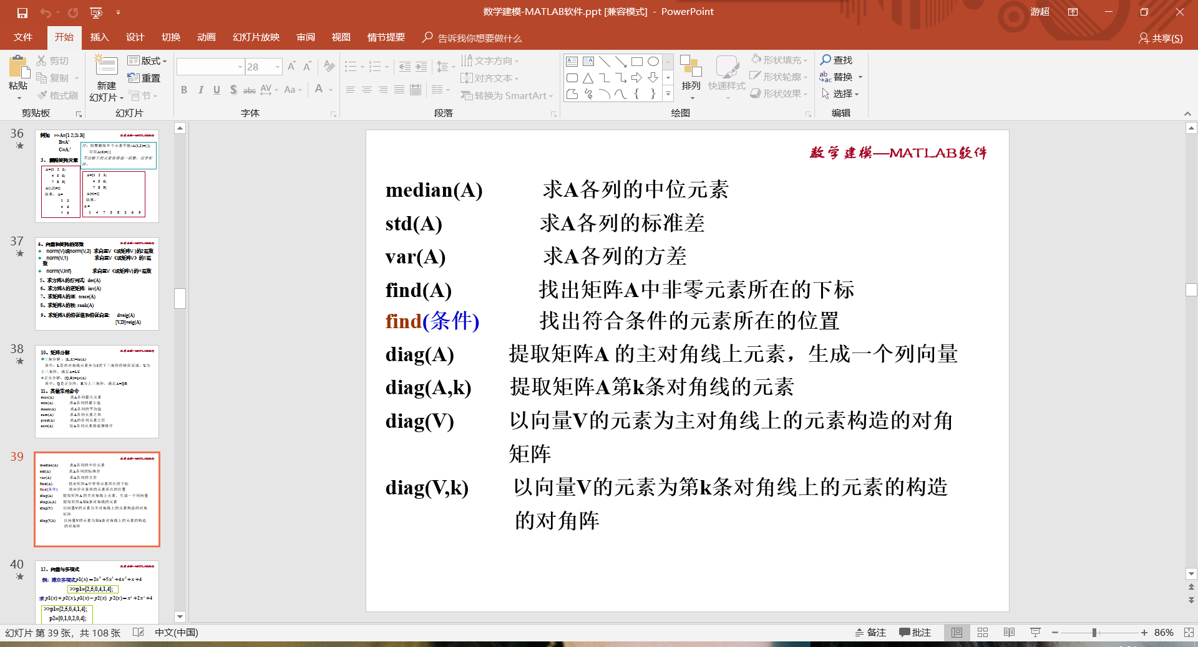

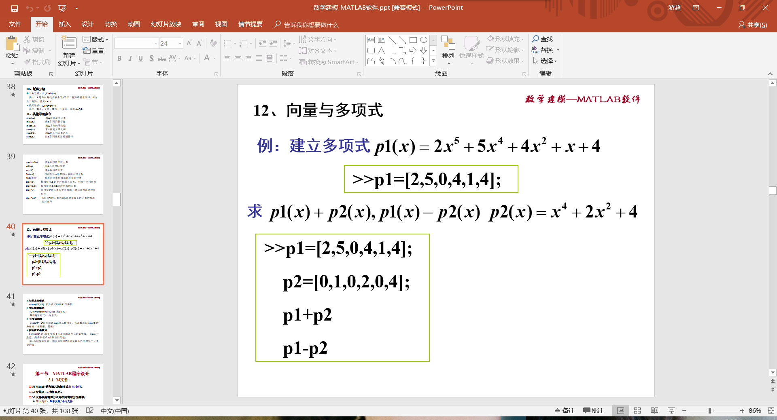

>> p1=[2,5,0,4,1,4]

p1 =

2 5 0 4 1 4

>> p2=[0,1,0,2,0,4]

p2 =

0 1 0 2 0 4

>> p1+p2

ans =

2 6 0 6 1 8

>> p1-p2

ans =

2 4 0 2 1 0

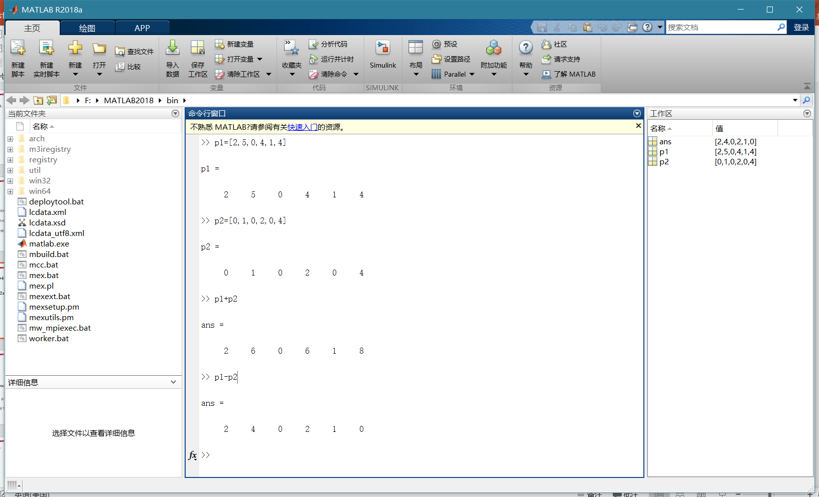

多项式乘法

>> conv(p1,p2)

ans =

0 2 5 4 14 9 32 2 24 4 16

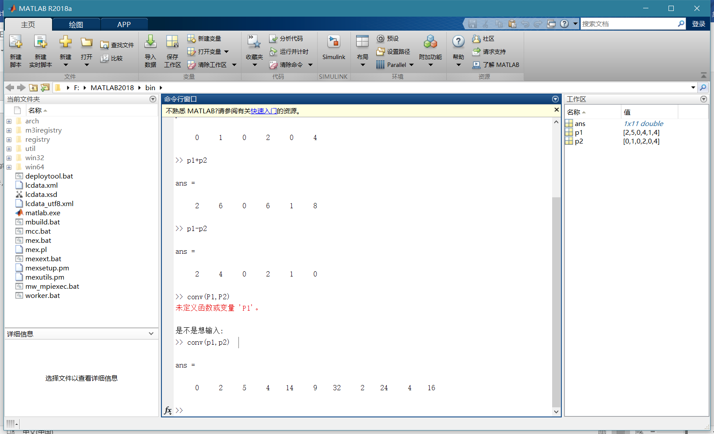

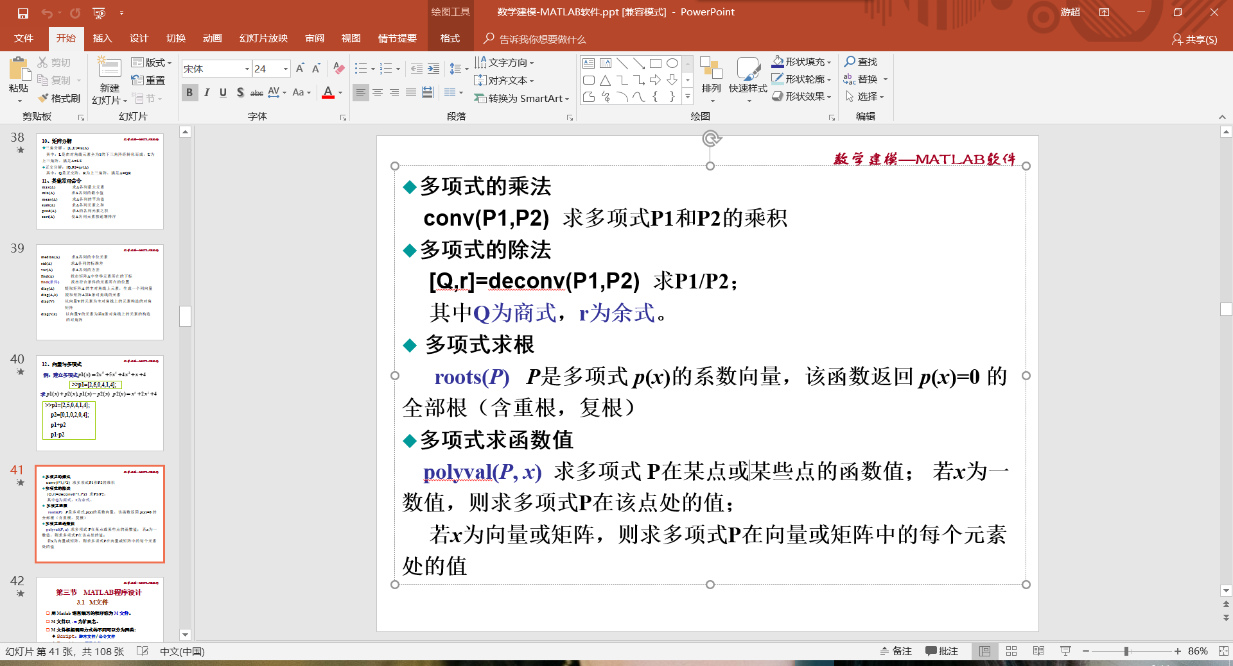

多项式求根

>> A=[1 2 1]

A =

1 2 1

>> roots(A)

ans =

-1

-1

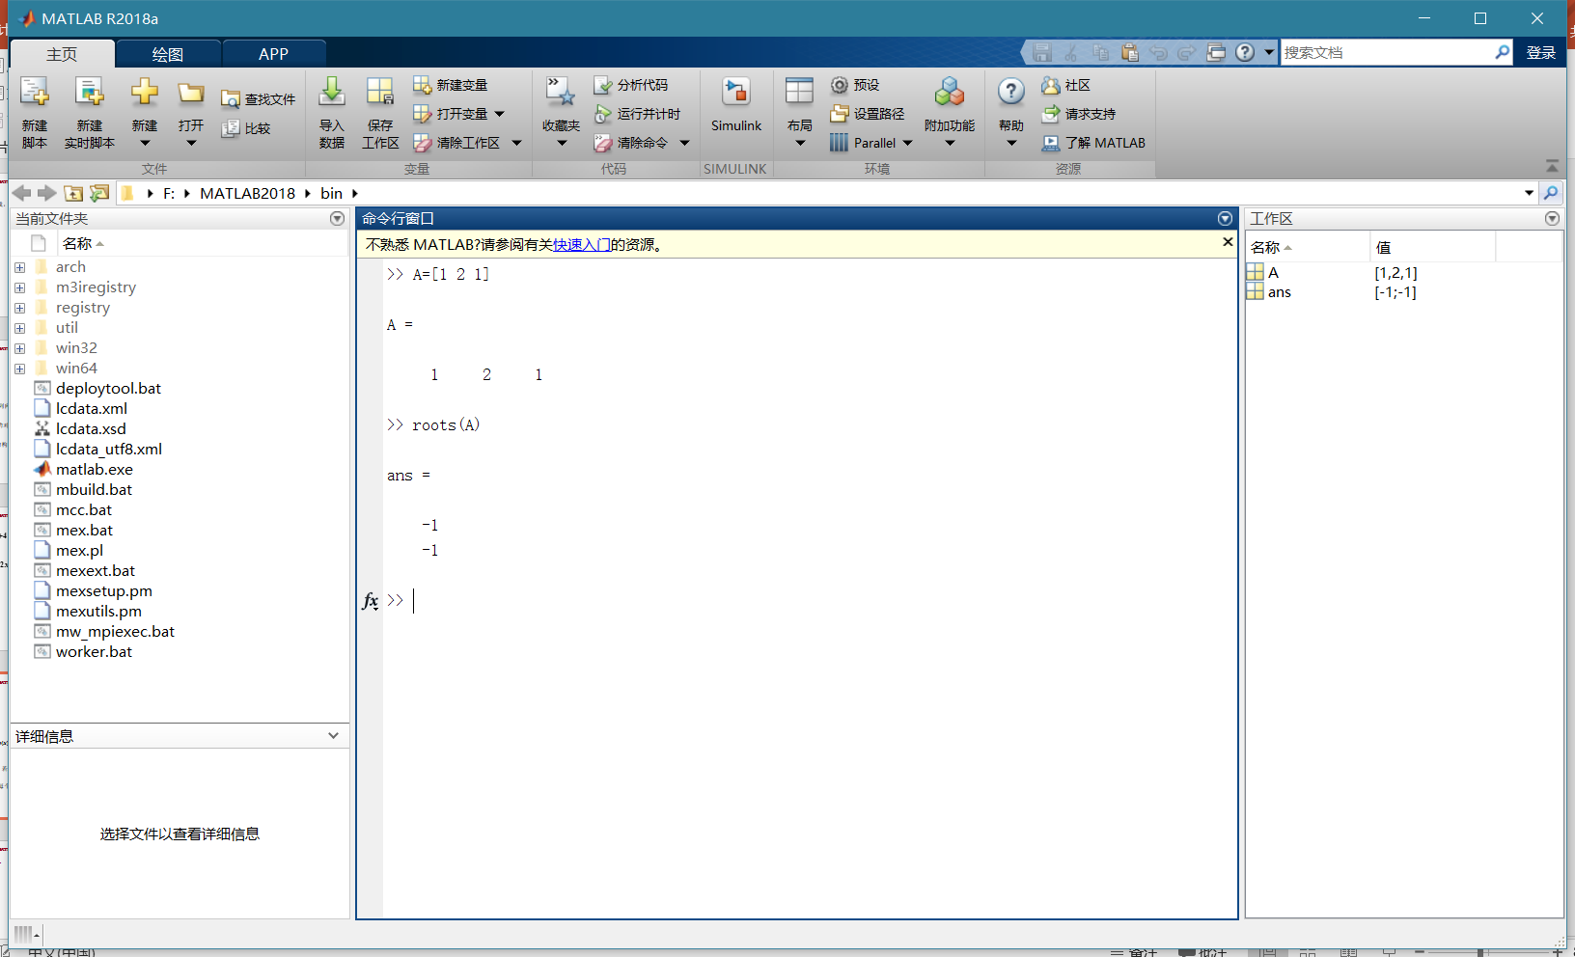

多项式求函数值

>> polyval(A,1)

ans =

4

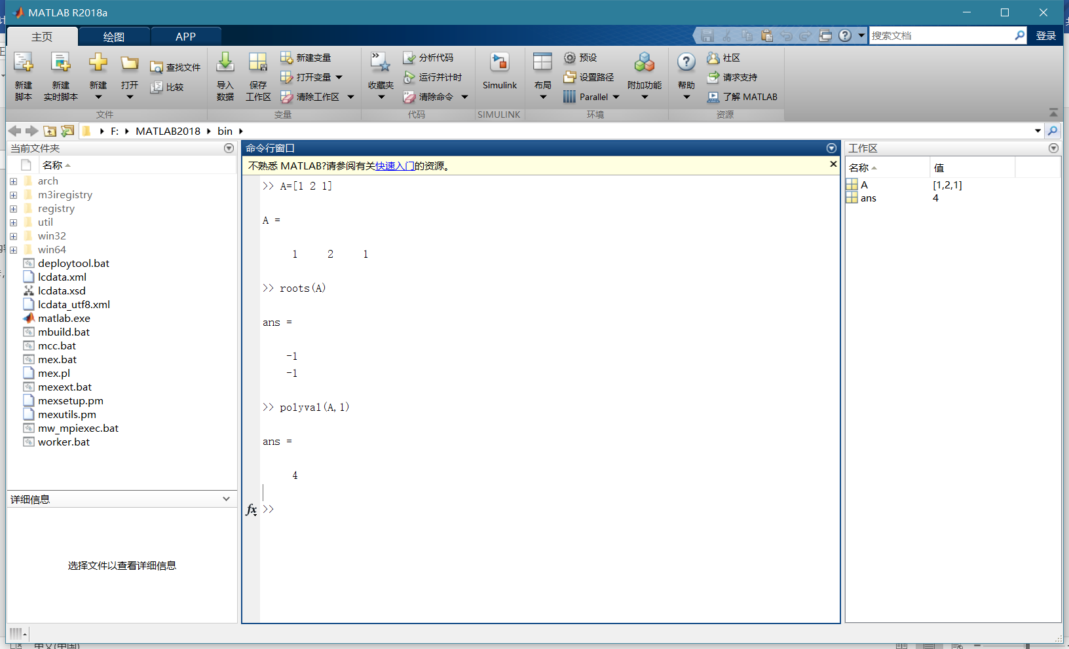

md函数体要顶格写啊

看了我半天md

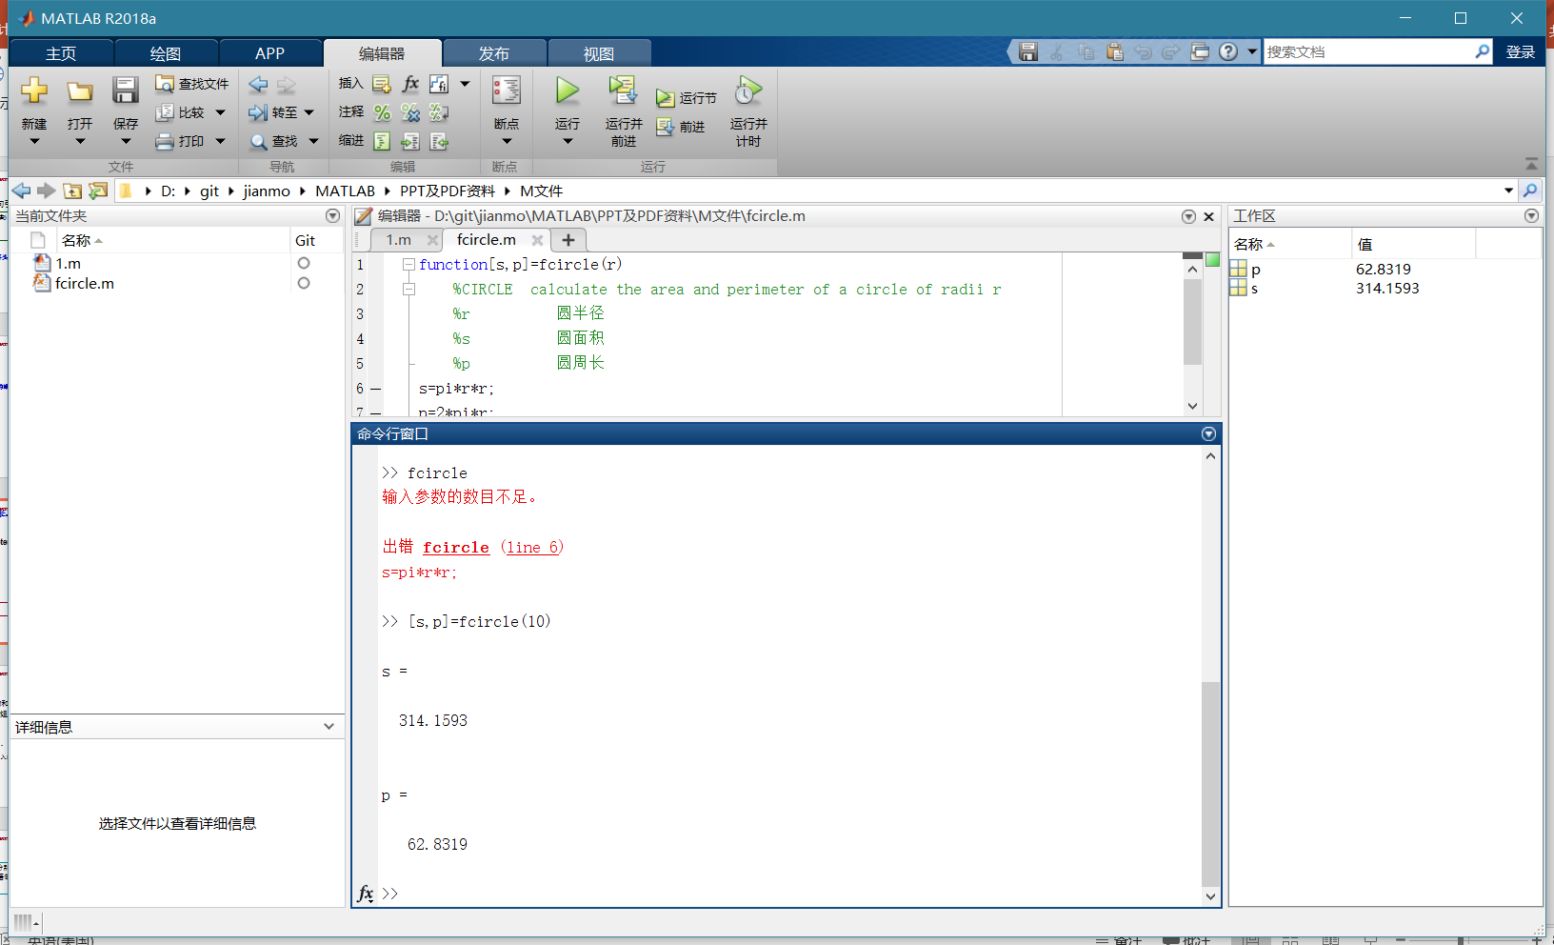

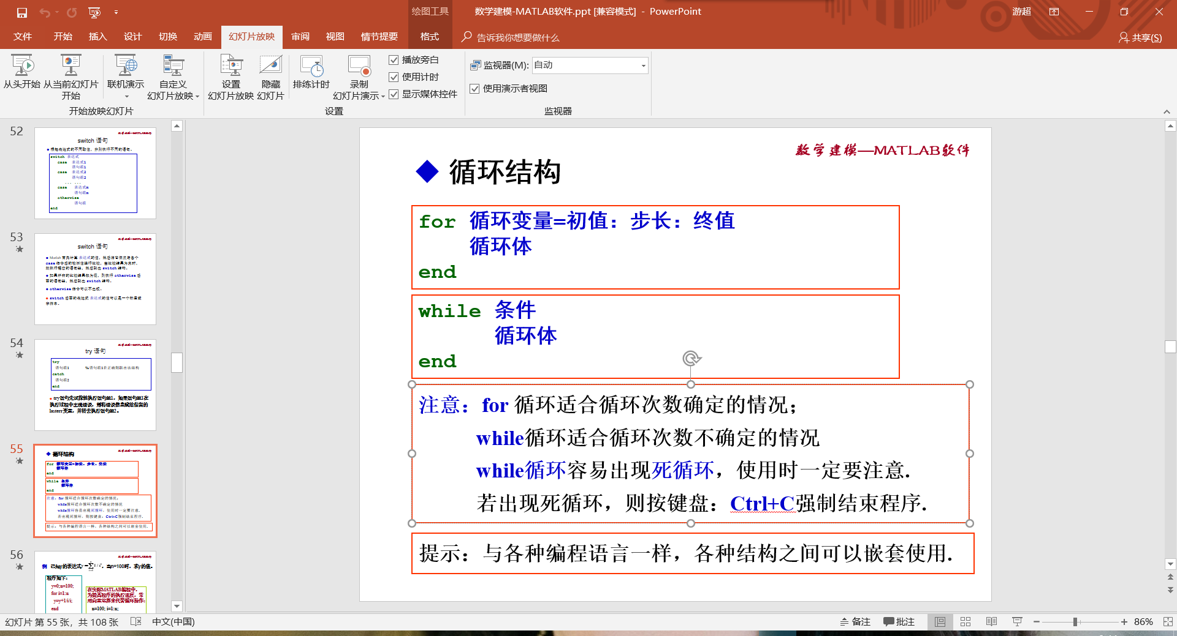

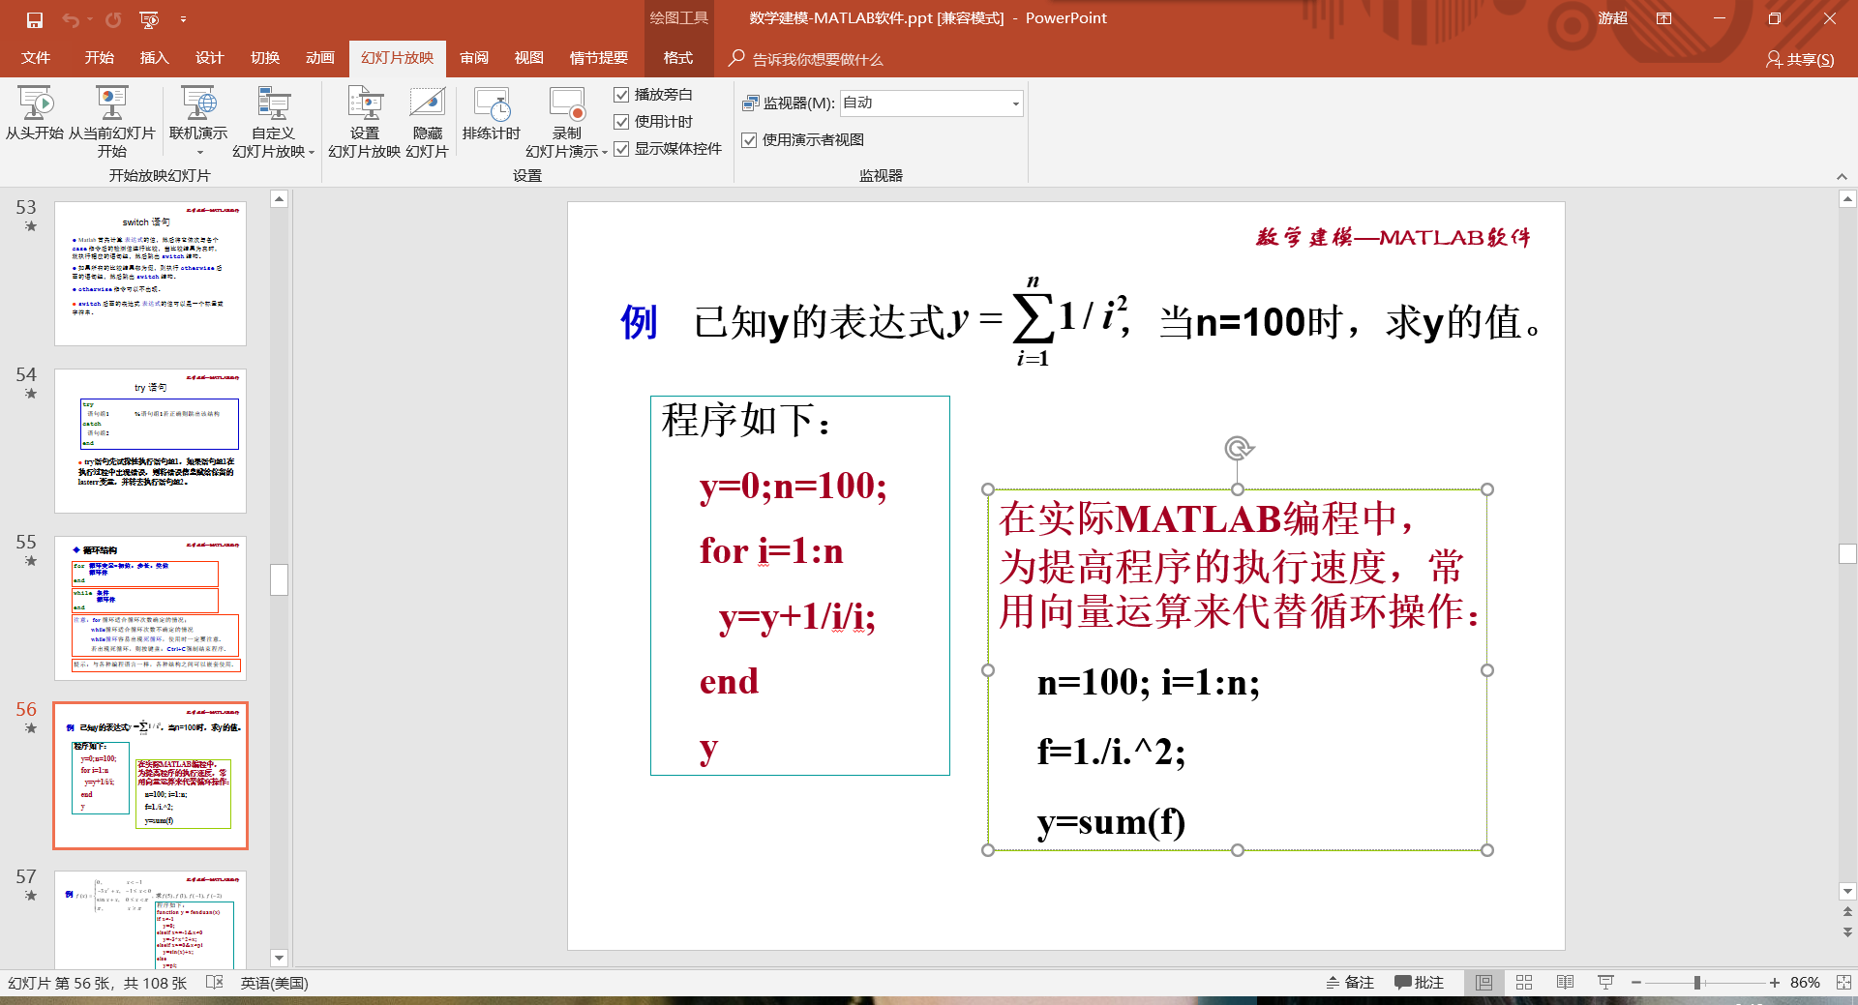

>> fun=@(x)0.*(x<-1)+(-3*x.^2+x).*(x>=-1&x<0)+(sin(x)+x).*(x>=0&x<pi)+pi.*(x>=pi)

fun =

包含以下值的 function_handle:

@(x)0.*(x<-1)+(-3*x.^2+x).*(x>=-1&x<0)+(sin(x)+x).*(x>=0&x<pi)+pi.*(x>=pi)

>> y=fun(-2)

y =

0

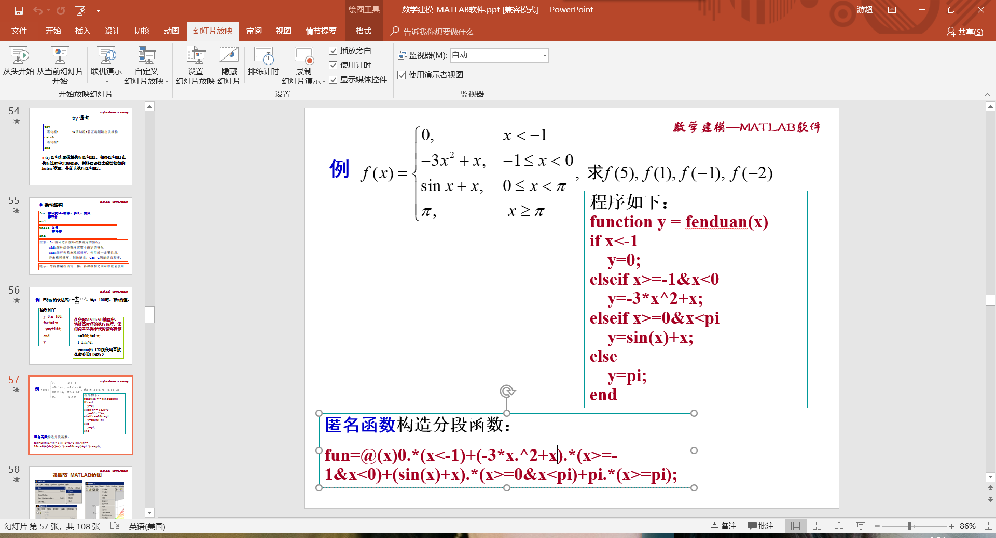

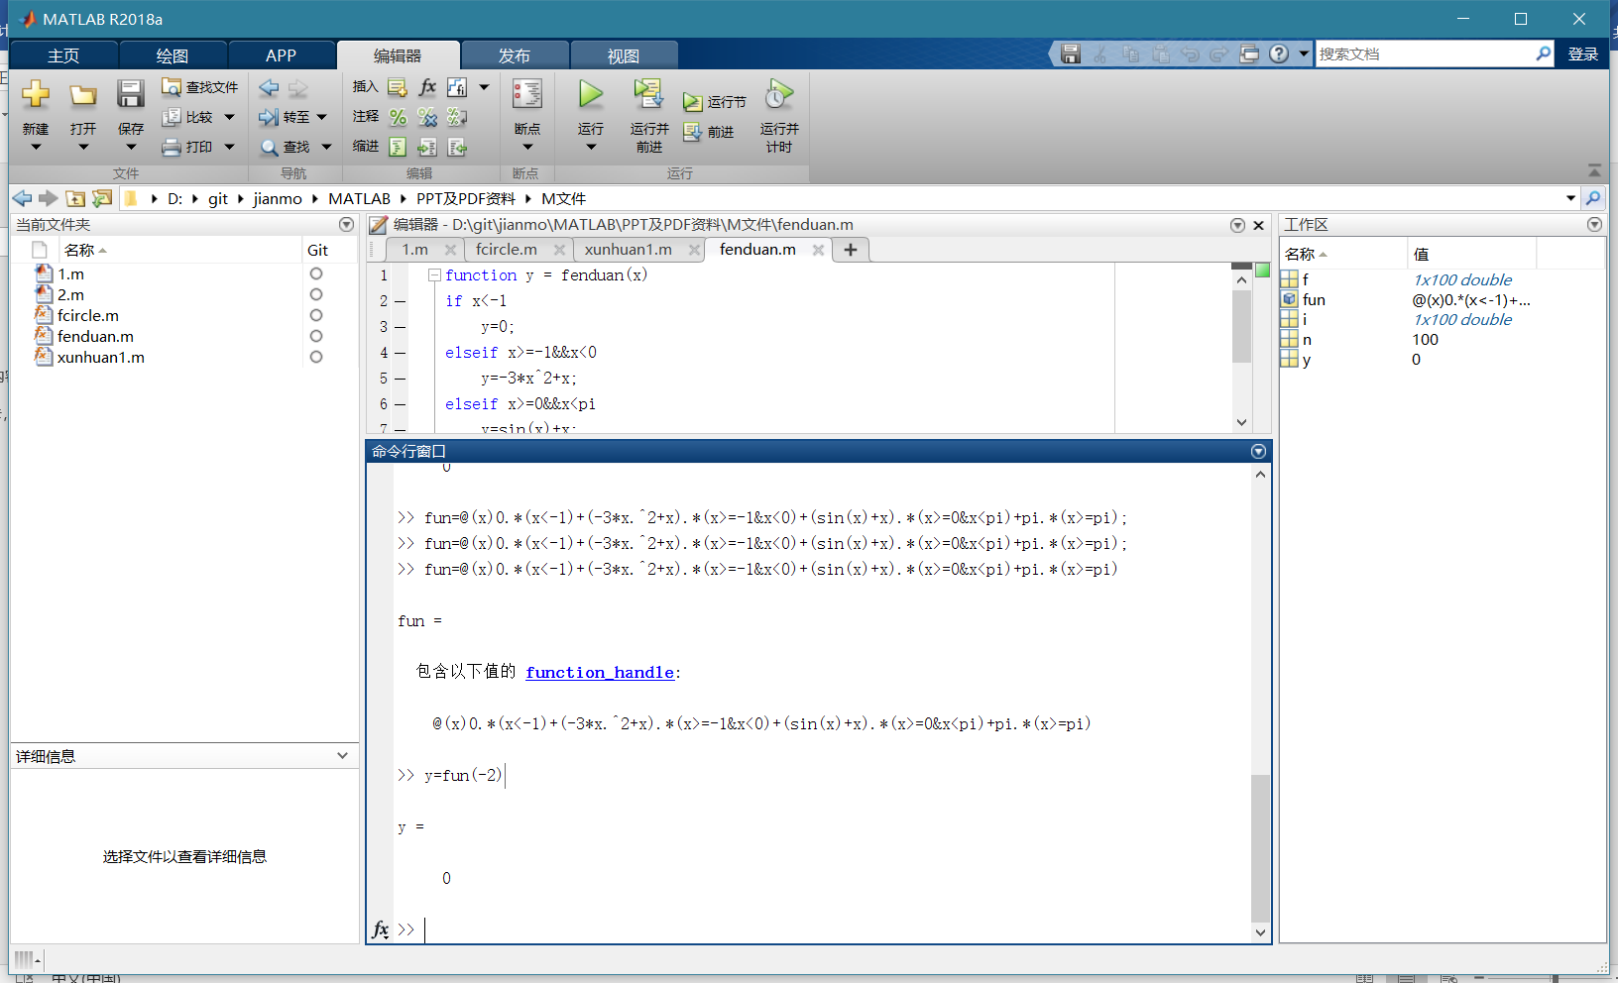

绘图

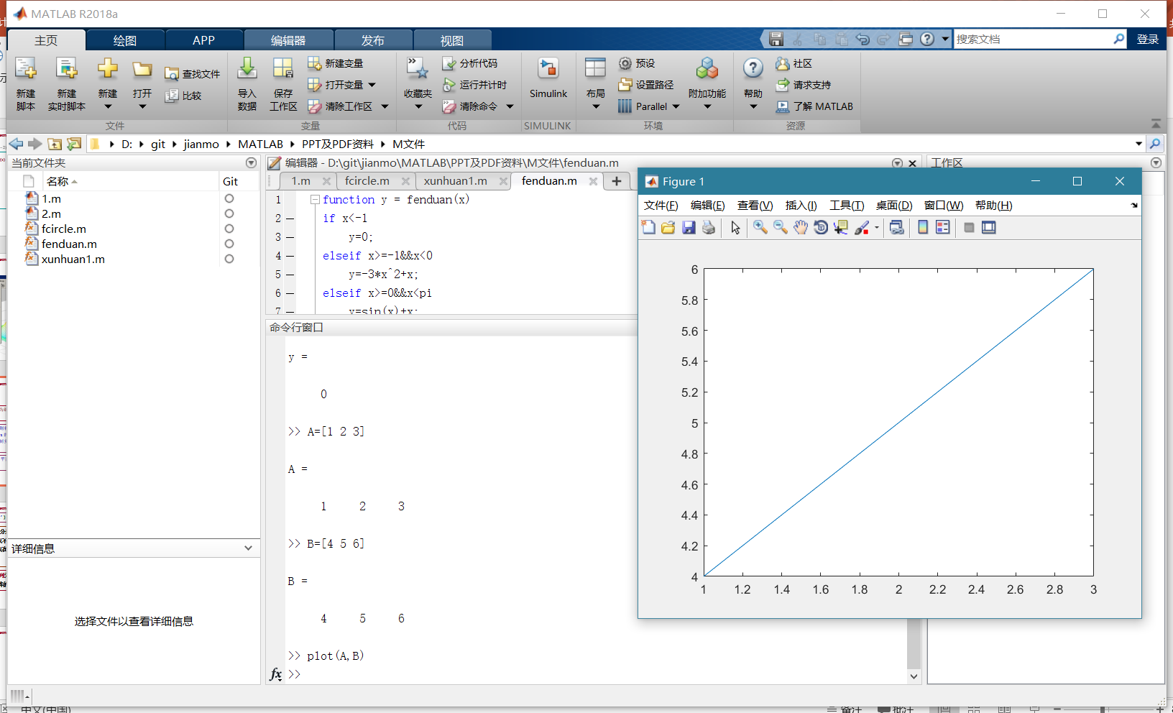

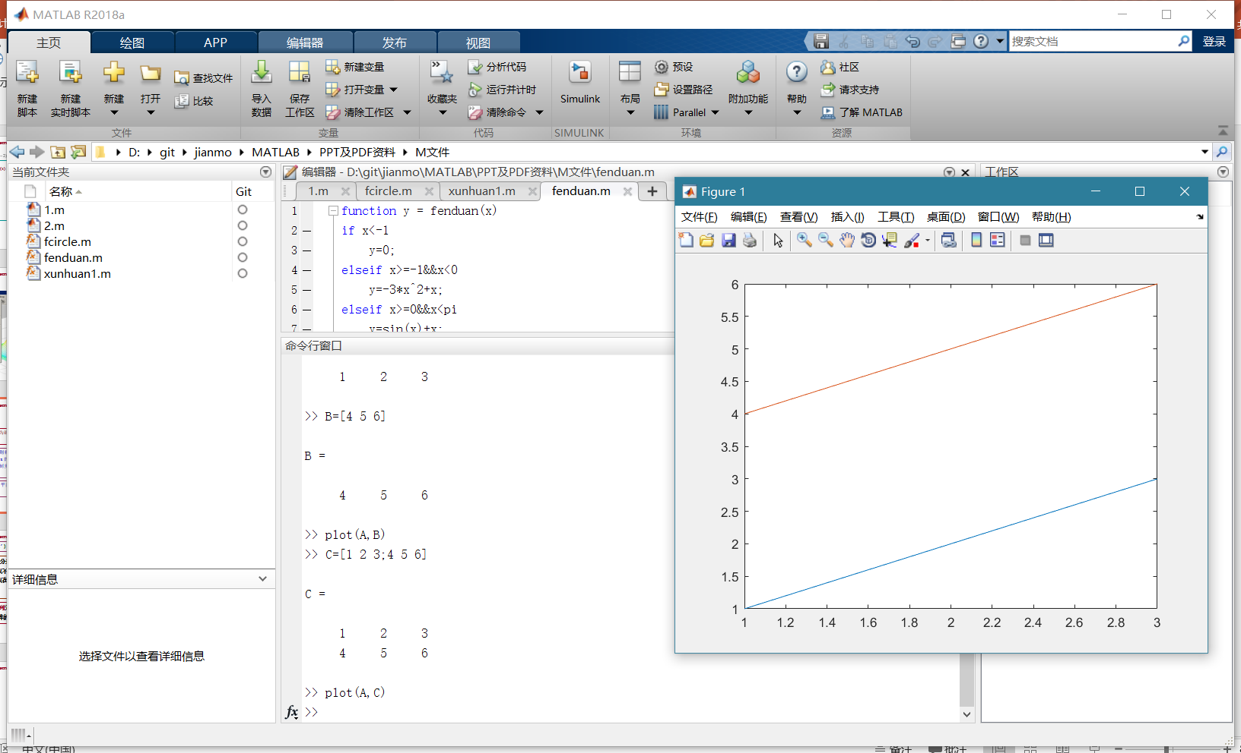

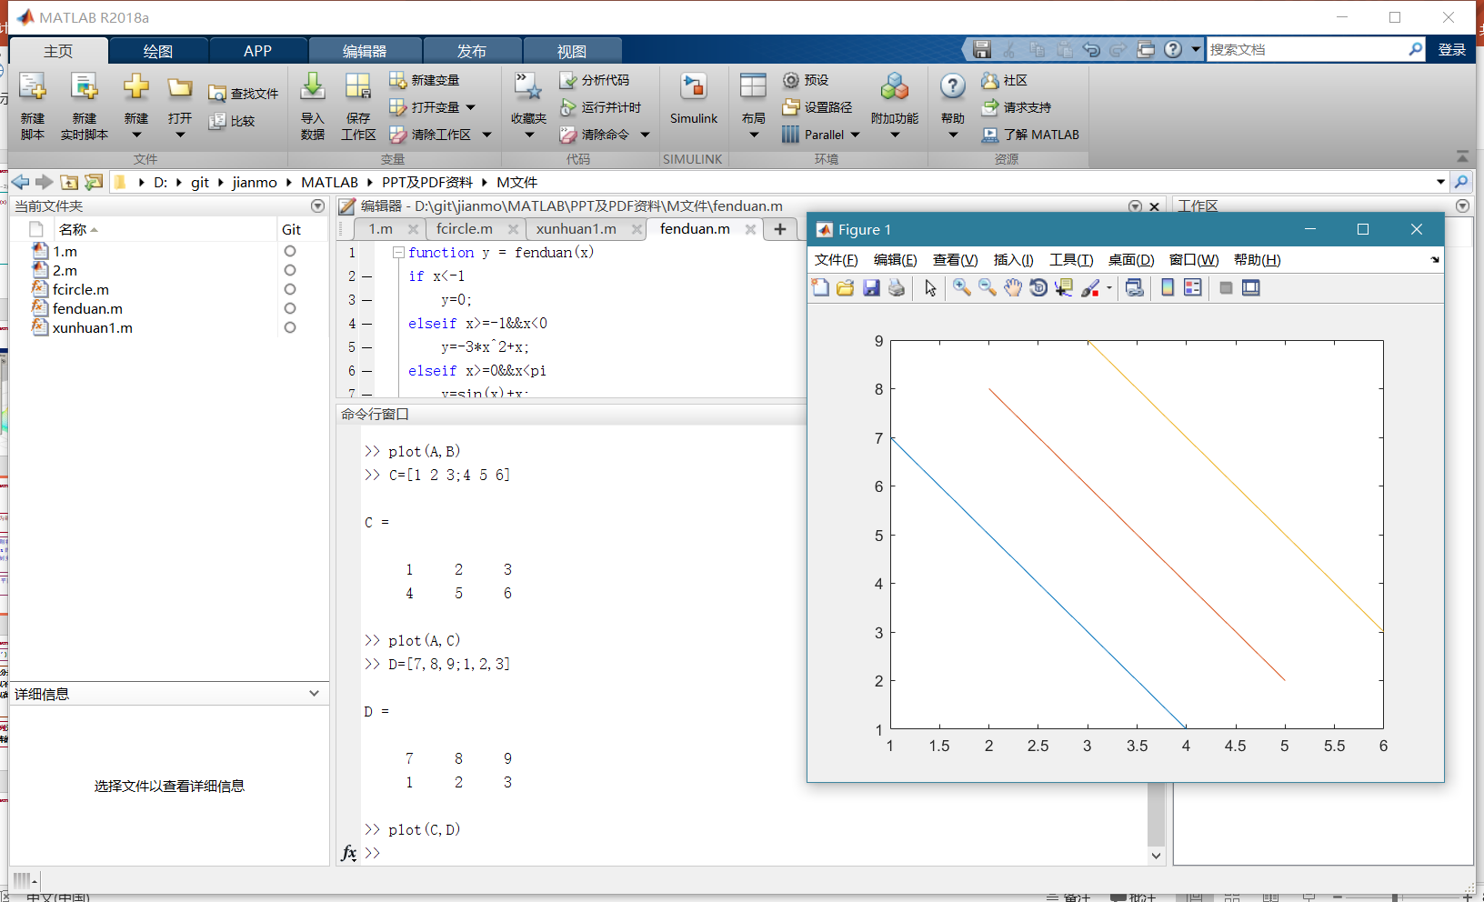

>> x=0:pi/15:2*pi

x =

1 至 9 列

0 0.2094 0.4189 0.6283 0.8378 1.0472 1.2566 1.4661 1.6755

10 至 18 列

1.8850 2.0944 2.3038 2.5133 2.7227 2.9322 3.1416 3.3510 3.5605

19 至 27 列

3.7699 3.9794 4.1888 4.3982 4.6077 4.8171 5.0265 5.2360 5.4454

28 至 31 列

5.6549 5.8643 6.0737 6.2832

>> y1=sin(x);

>> y1=sin(x)

y1 =

1 至 9 列

0 0.2079 0.4067 0.5878 0.7431 0.8660 0.9511 0.9945 0.9945

10 至 18 列

0.9511 0.8660 0.7431 0.5878 0.4067 0.2079 0.0000 -0.2079 -0.4067

19 至 27 列

-0.5878 -0.7431 -0.8660 -0.9511 -0.9945 -0.9945 -0.9511 -0.8660 -0.7431

28 至 31 列

-0.5878 -0.4067 -0.2079 -0.0000

>> y2=cos(x)

y2 =

1 至 9 列

1.0000 0.9781 0.9135 0.8090 0.6691 0.5000 0.3090 0.1045 -0.1045

10 至 18 列

-0.3090 -0.5000 -0.6691 -0.8090 -0.9135 -0.9781 -1.0000 -0.9781 -0.9135

19 至 27 列

-0.8090 -0.6691 -0.5000 -0.3090 -0.1045 0.1045 0.3090 0.5000 0.6691

28 至 31 列

0.8090 0.9135 0.9781 1.0000

>> plot(x,y1,'b:+',x,y2,'g-.*')

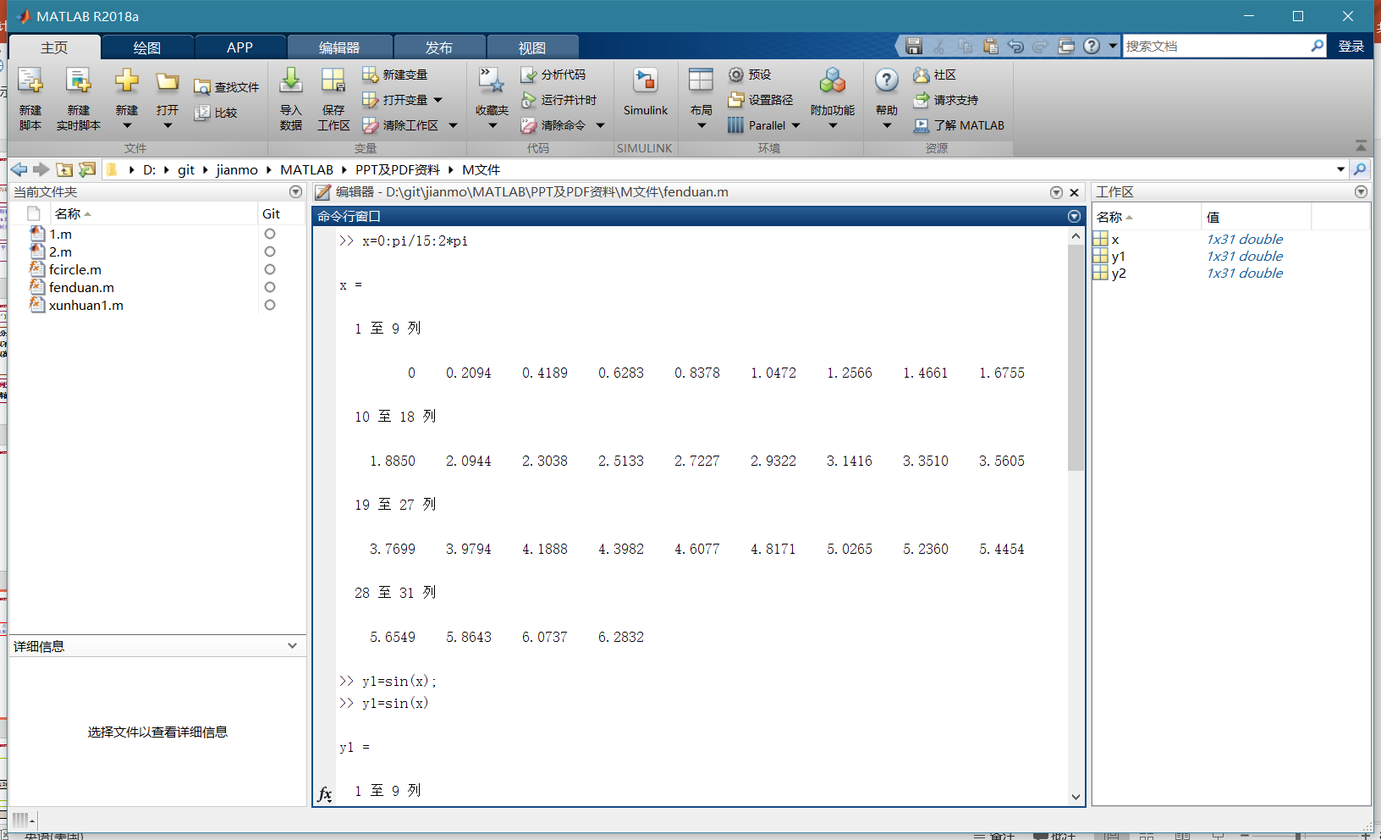

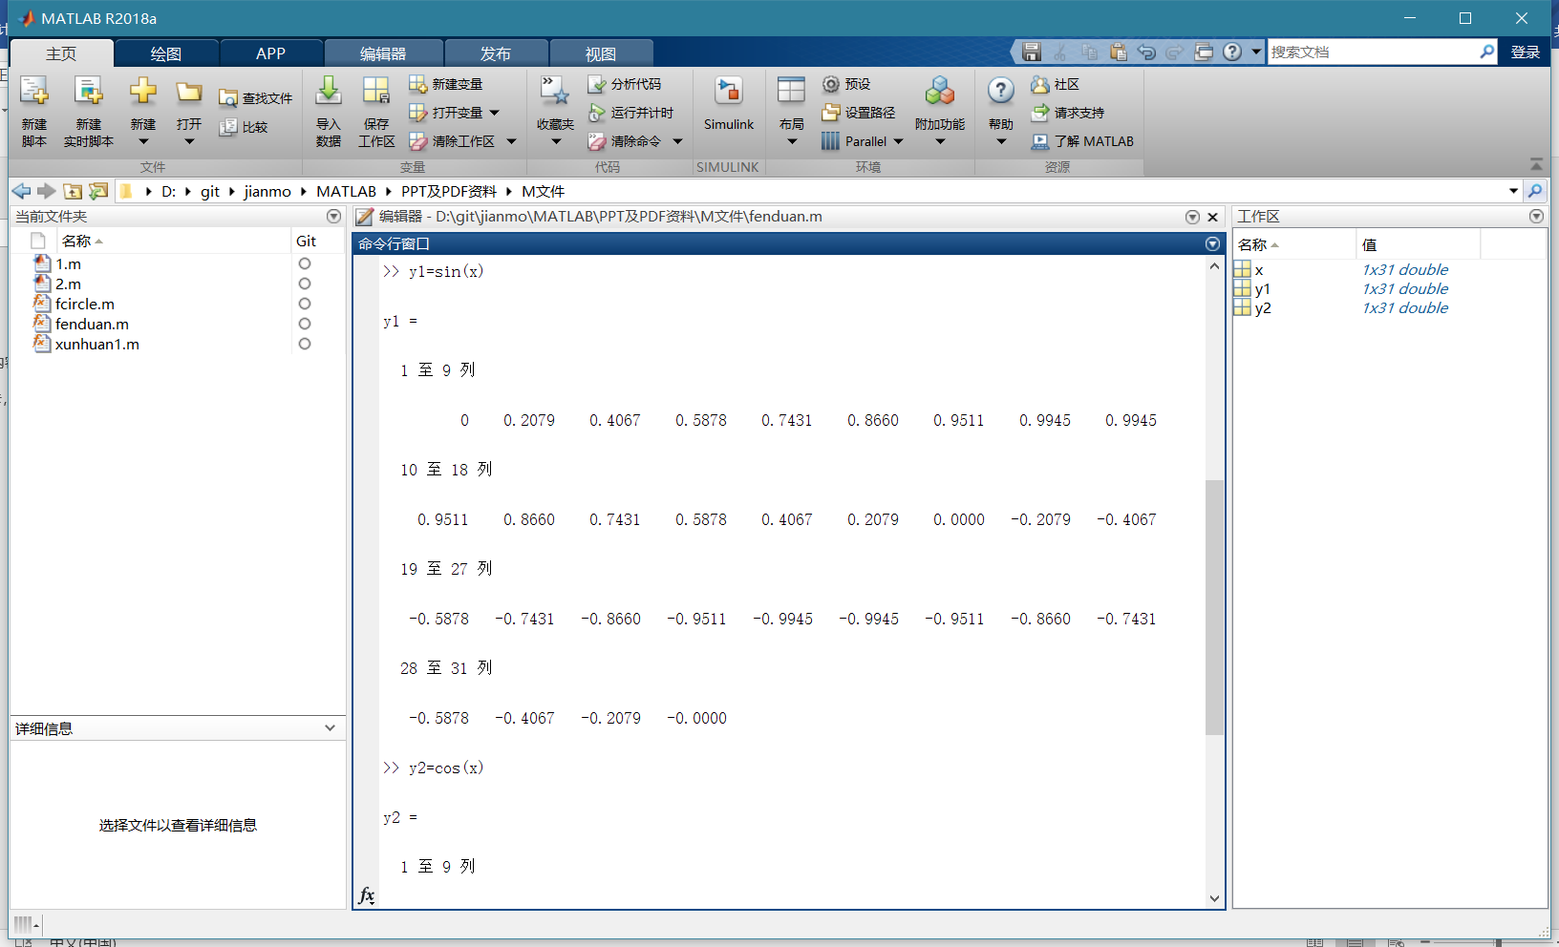

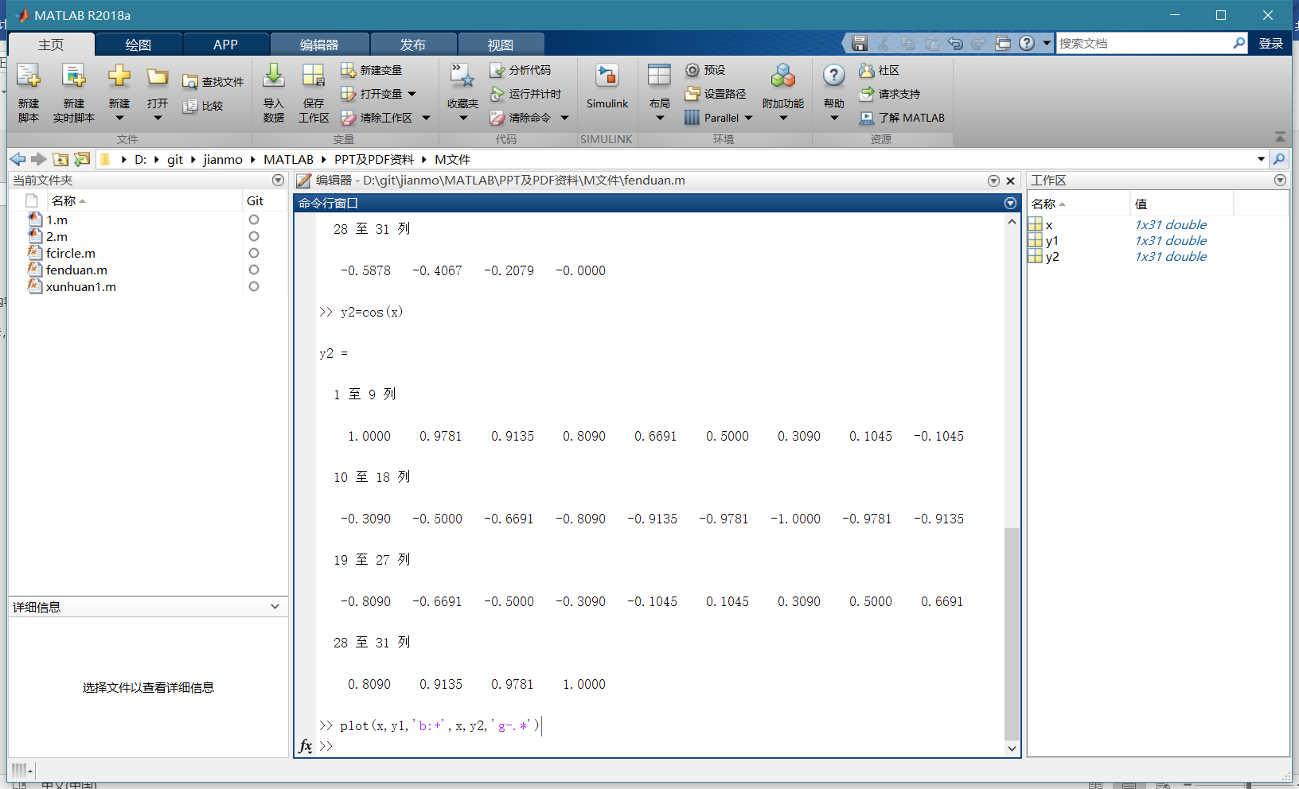

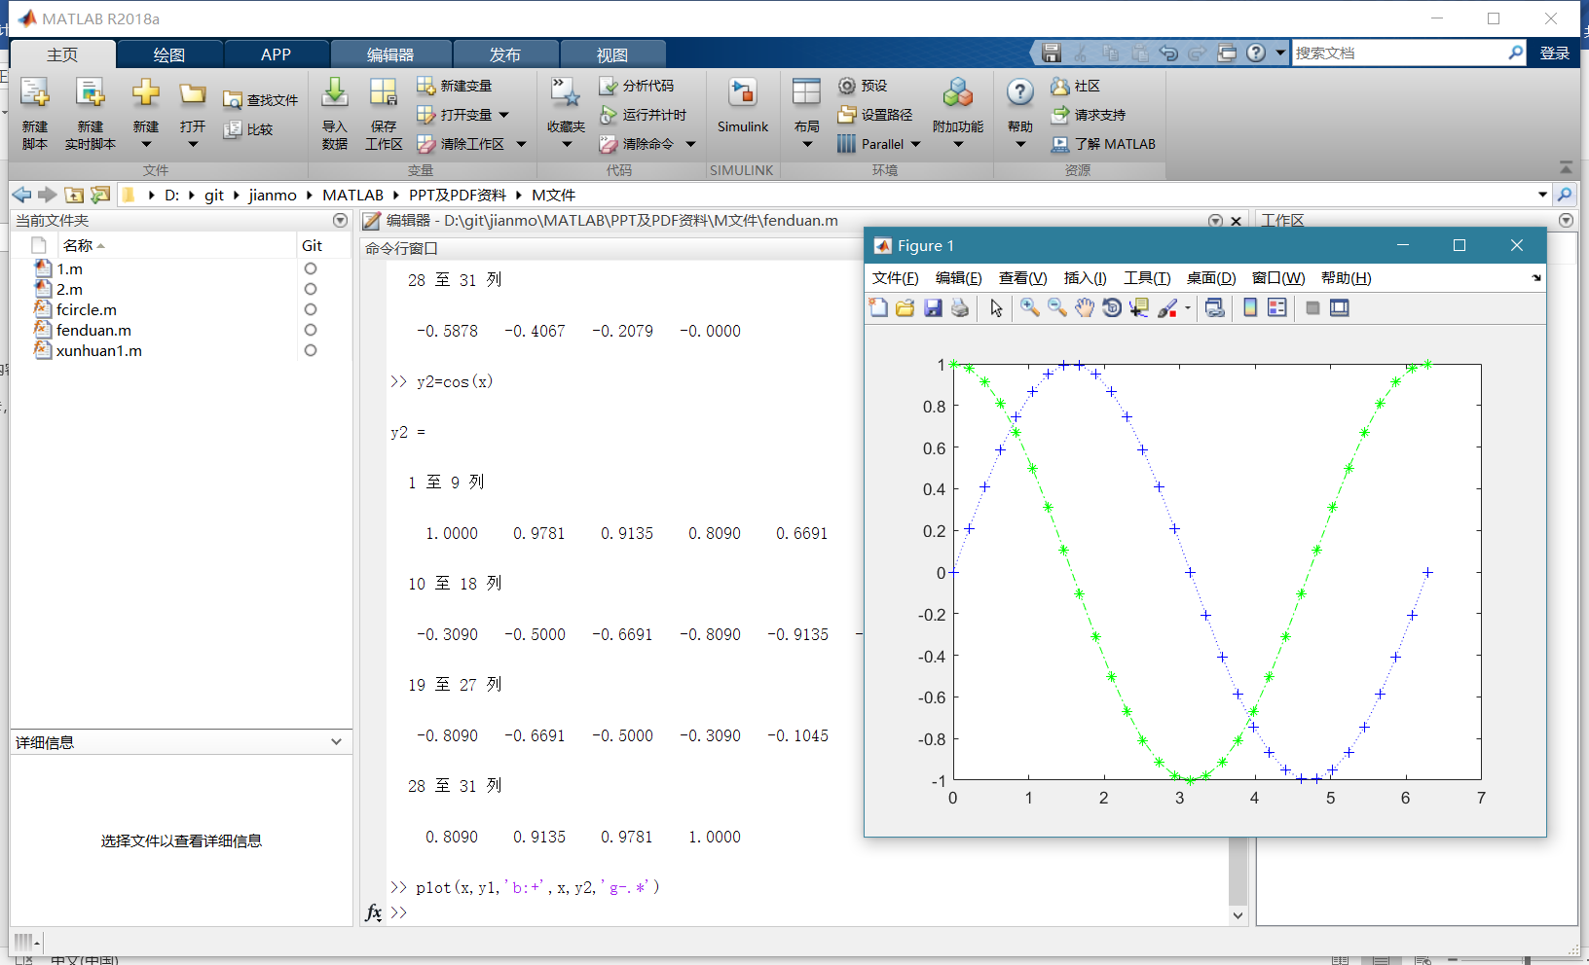

>> ezplot('sin(x)')

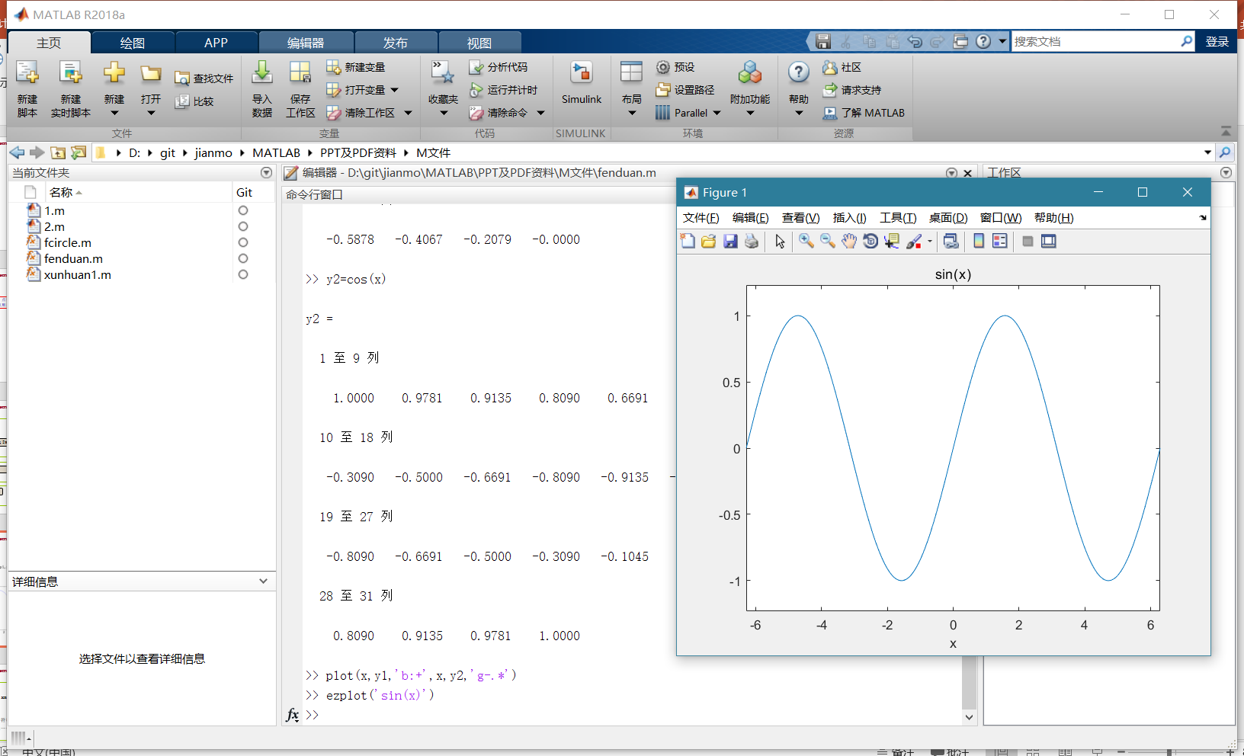

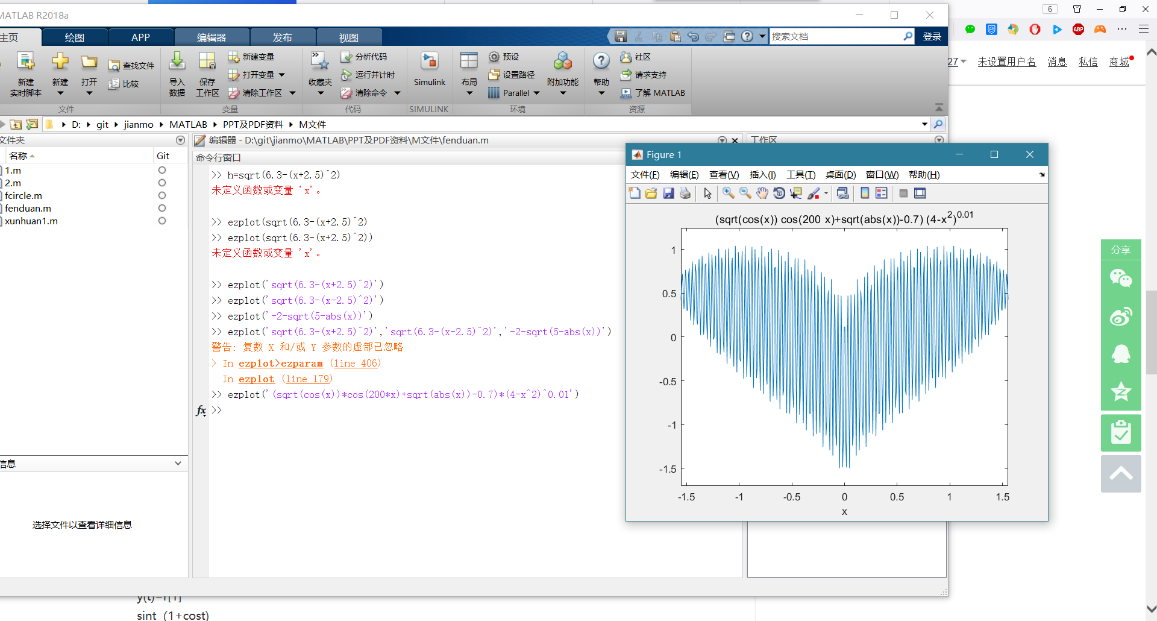

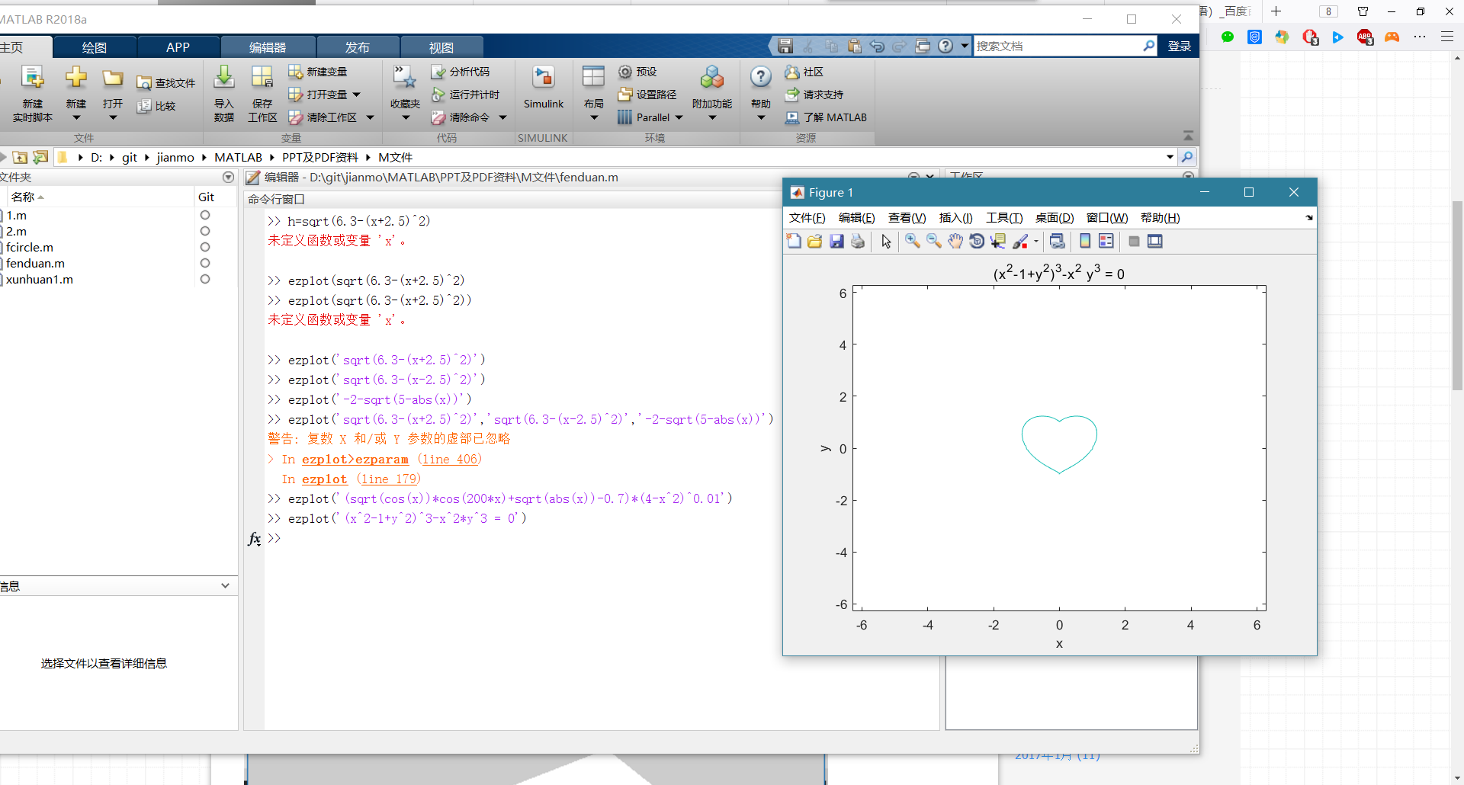

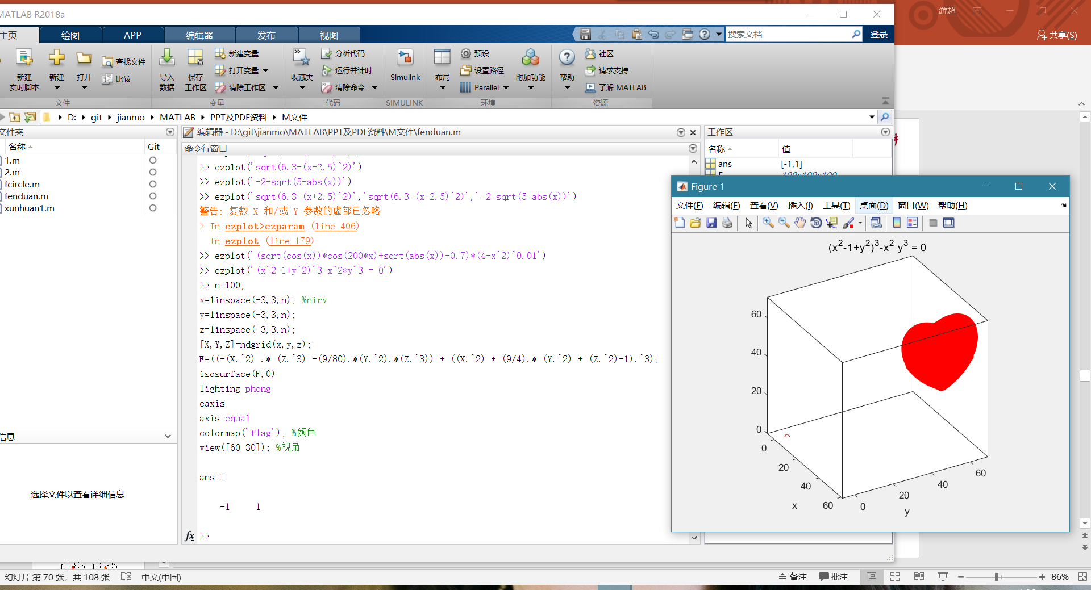

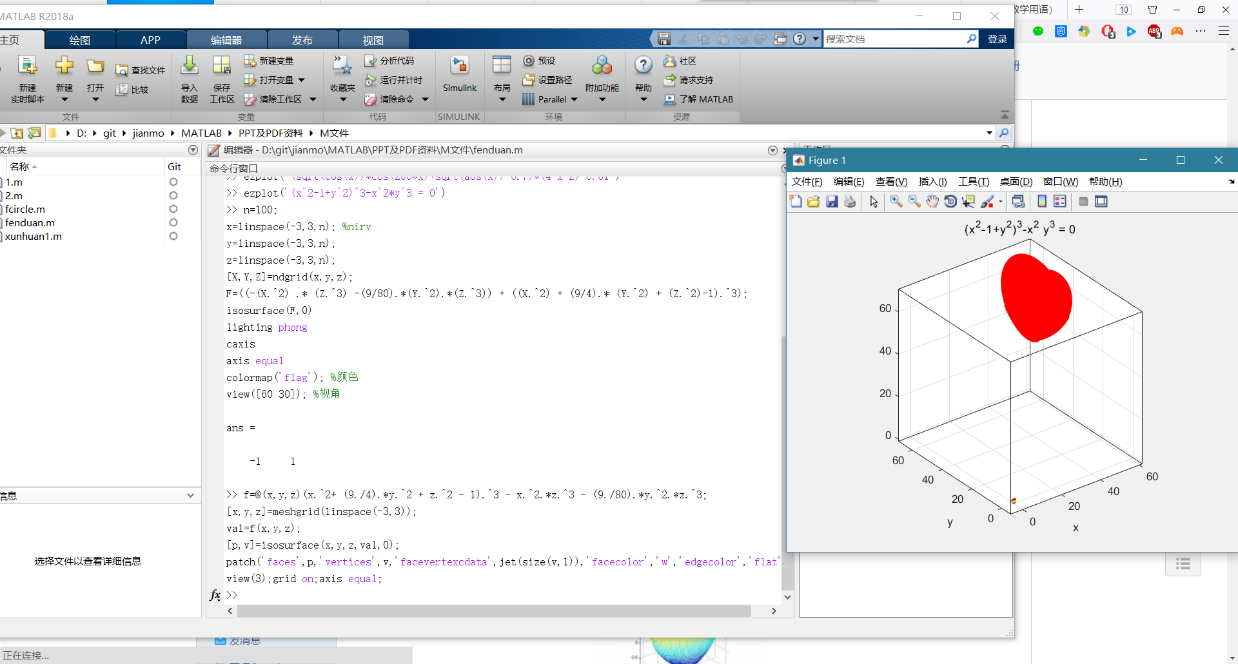

filename='heart';

[x,y,z]=meshgrid(linspace(-3,3));

p=(x.^2+(9/4)*y.^2+z.^2-1).^3-x.^2.*z.^3-(9/80)*y.^2.*z.^3;

[faces,verts,colors] = isosurface(x,y,z,p,0,x);

for i=1:9

figure(i)

pp=patch('Faces',faces(1:284+i*1000,:),'Vertices',verts);

set(pp,'FaceColor','red','EdgeColor','none');

view(-30,24)

axis off

axis equal

axis tight

camlight

lighting gouraud

pause(0.5)

f(i) = getframe(i);

imind = frame2im(f(i));

[imind,cm] = rgb2ind(imind,256);

if i == 1

imwrite(imind,cm,filename,'gif', 'Loopcount',inf,'DelayTime',0.5);

else

imwrite(imind,cm,filename,'gif','WriteMode','append','DelayTime',0.5);

end

%close(i)

%[plain] view plain copy

end

